**Data base systems Lab manual**

**Lab1**

CREATE TABLE employee(empid int, FirstName varchar(20) , LastName varchar(20) , Course varchar(20) , Credit int);

INSERT INTO employee(empid , FirstName , LastName , Course , Credit) VALUES (101 , 'Xiao' , 'Zhan' , 'DBMS' , 3);

INSERT INTO employee(empid , FirstName , LastName , Course , Credit) VALUES (102 , 'Wang' , 'Yibo' , 'COA' , 3);

INSERT INTO employee(empid , FirstName , LastName , Course , Credit) VALUES (103 , 'Fang' , 'Leng' , 'QS' , 4);

INSERT INTO employee(empid , FirstName , LastName , Course , Credit) VALUES (103 , 'Fangi' , 'Lie' , 'OS' , 4);

INSERT INTO employee(empid , FirstName , LastName , Course , Credit) VALUES (104 , 'Wei' , 'Wuxian' , 'ML' , 2);

UPDATE employee SET empid = '104' where FirstName = 'Fangi';

UPDATE employee SET empid = '105' where FirstName = 'Wei';

INSERT INTO employee(empid , FirstName , LastName , Course , Credit) VALUES (106 , 'Lan' , 'Wanji' , 'DSA' , 3);

Select * from employee;

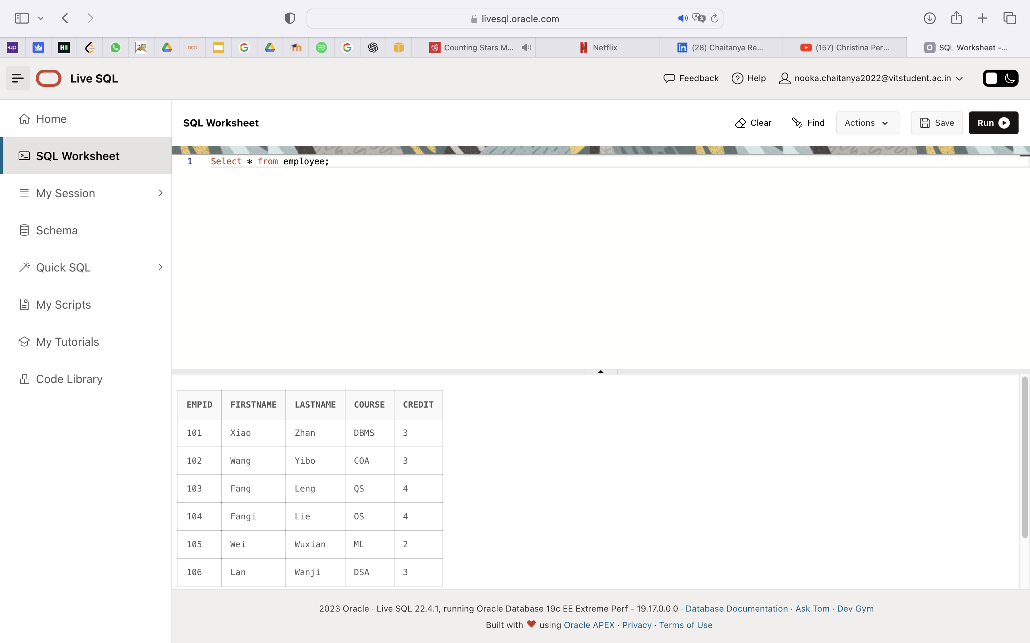

Delete from employee WHERE FirstName = 'Lan';

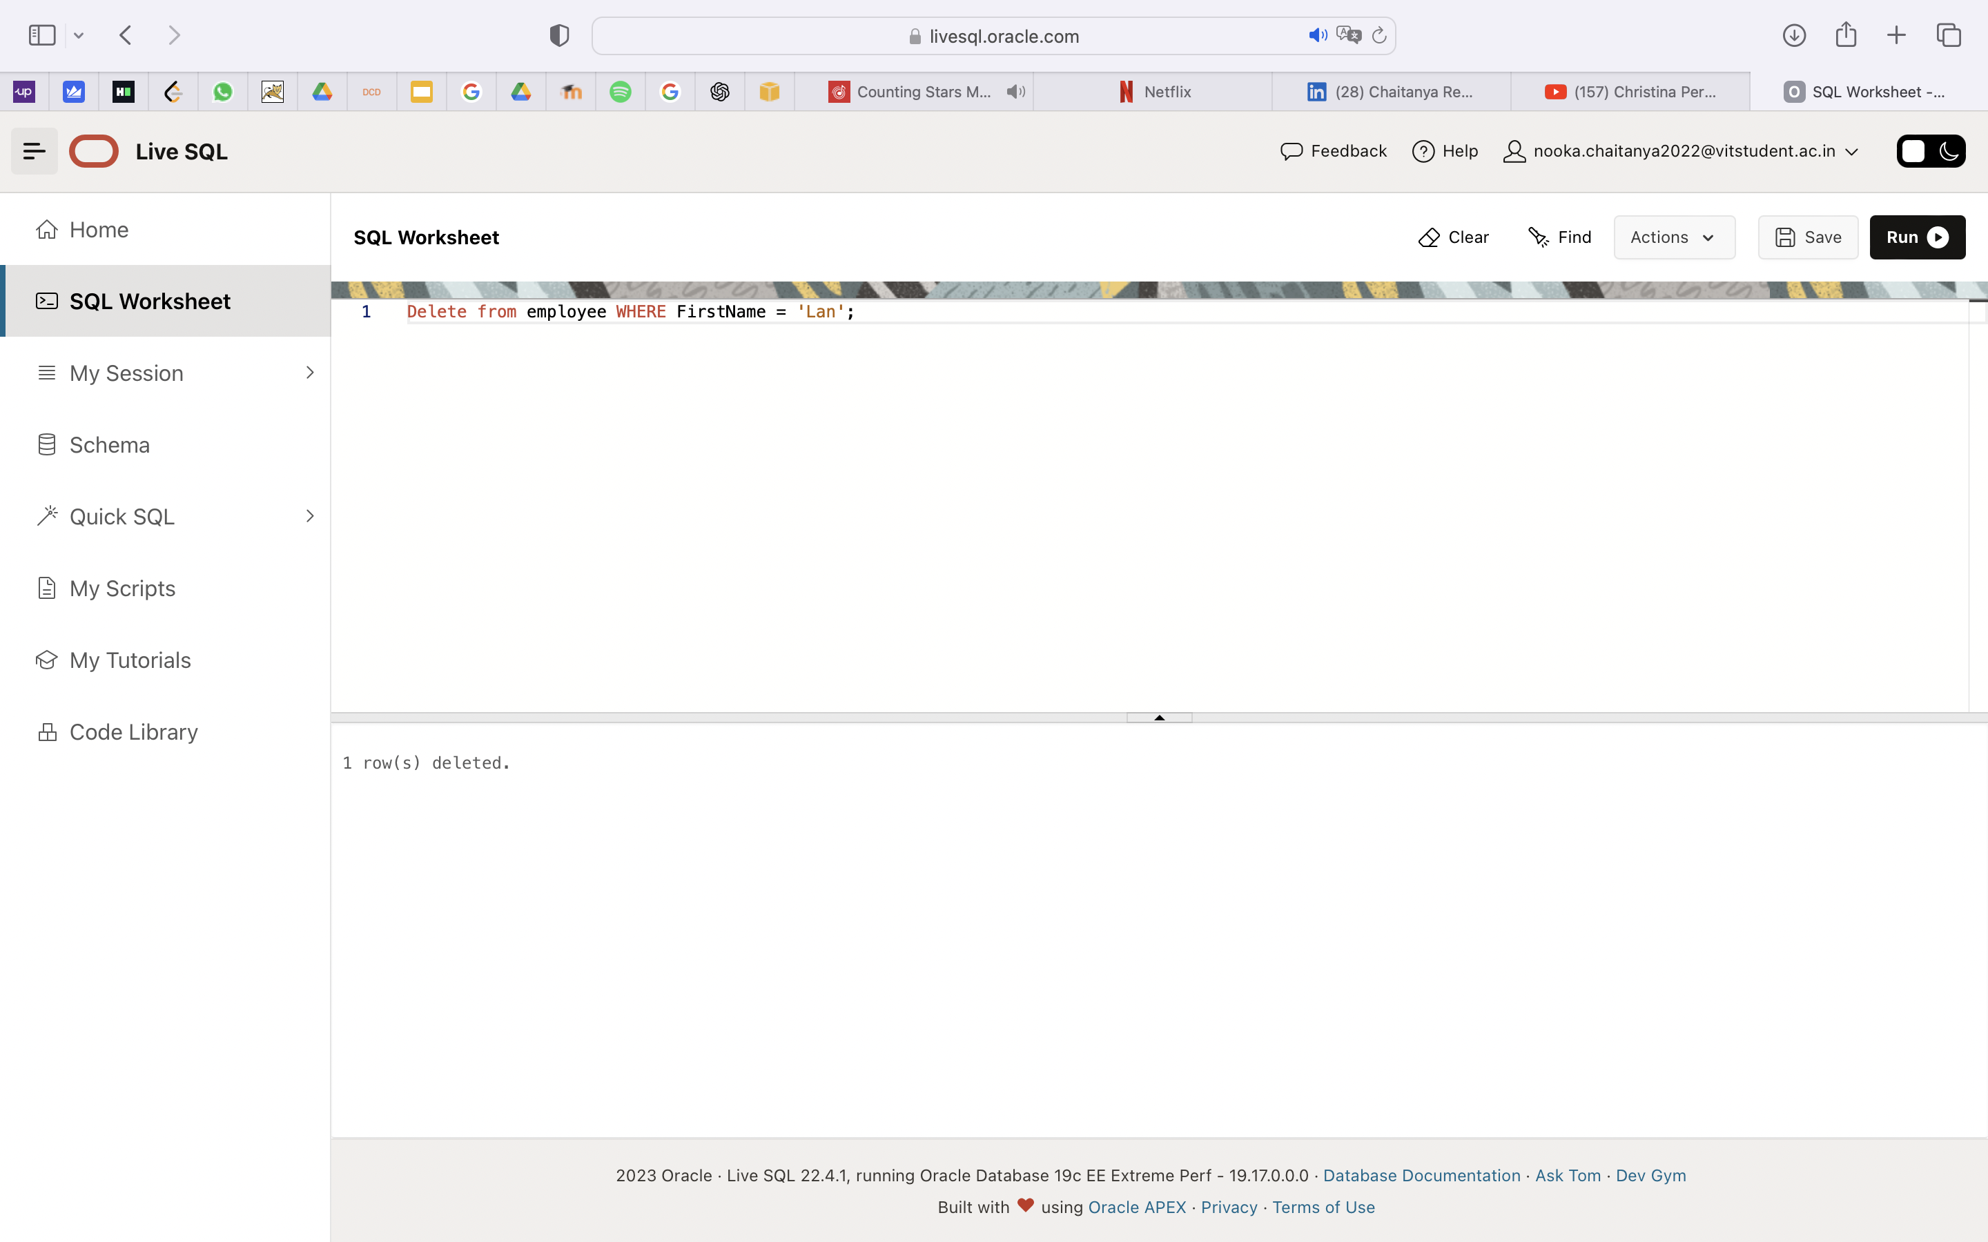

Select * from employee;

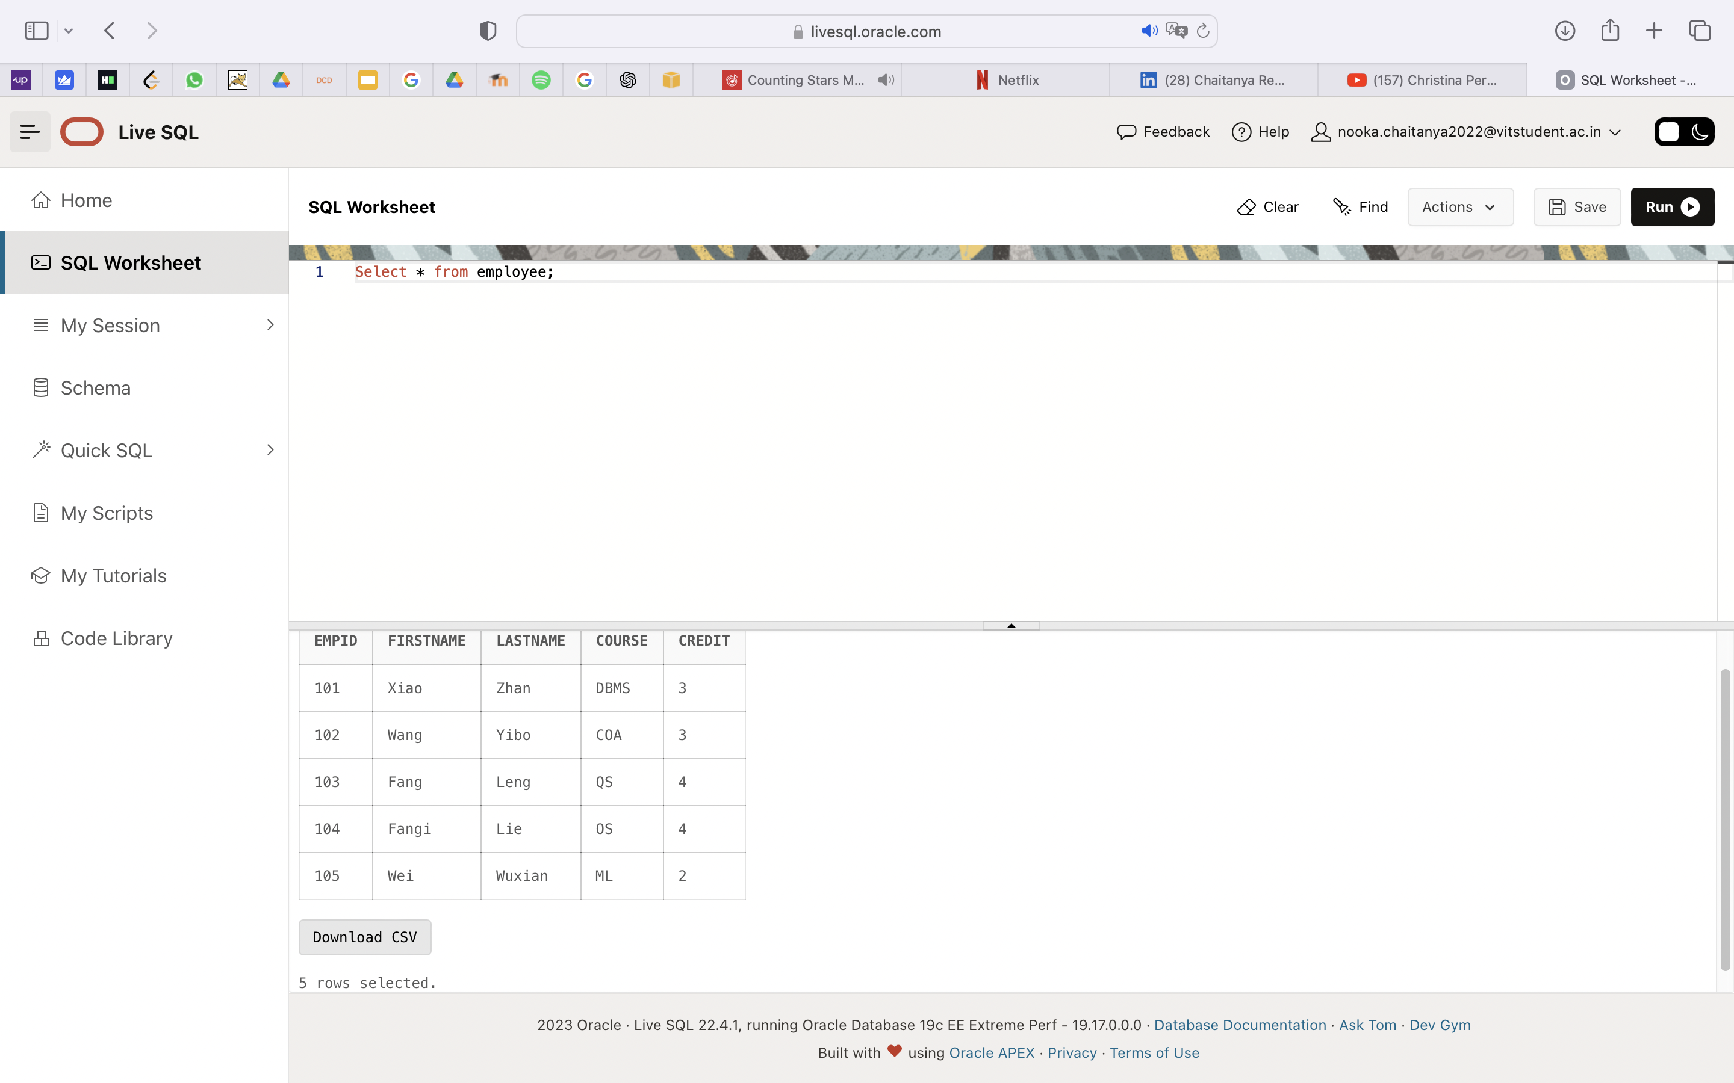

Alter Table employee ADD PRIMARY KEY (empid);

drop TABLE employee;

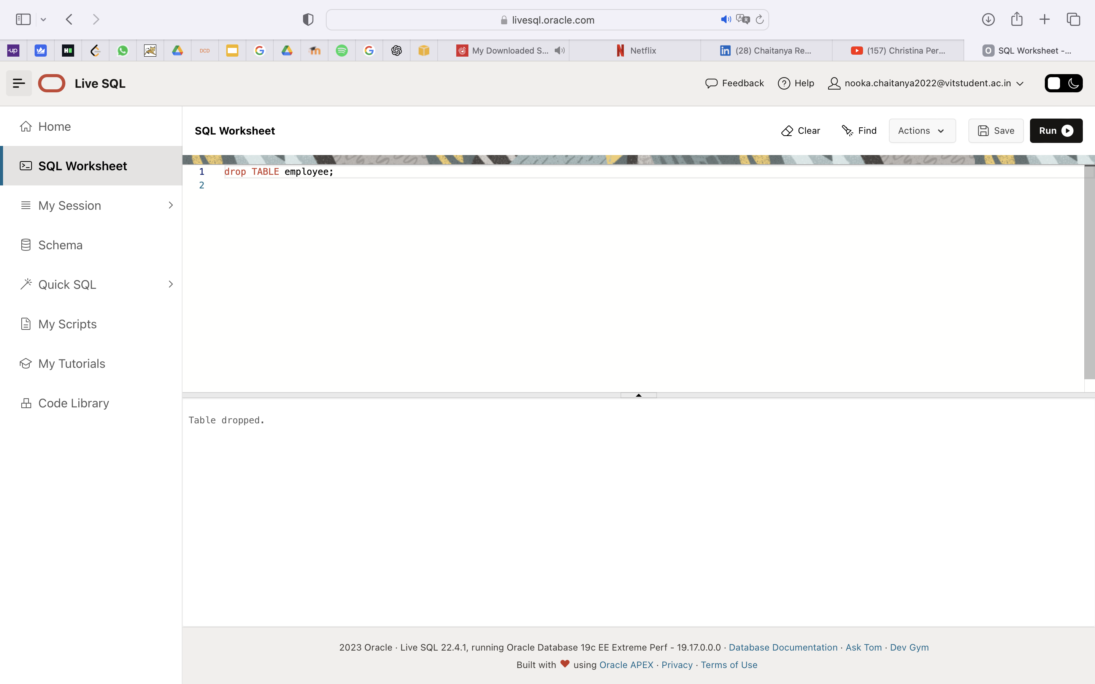

**LAB-3**

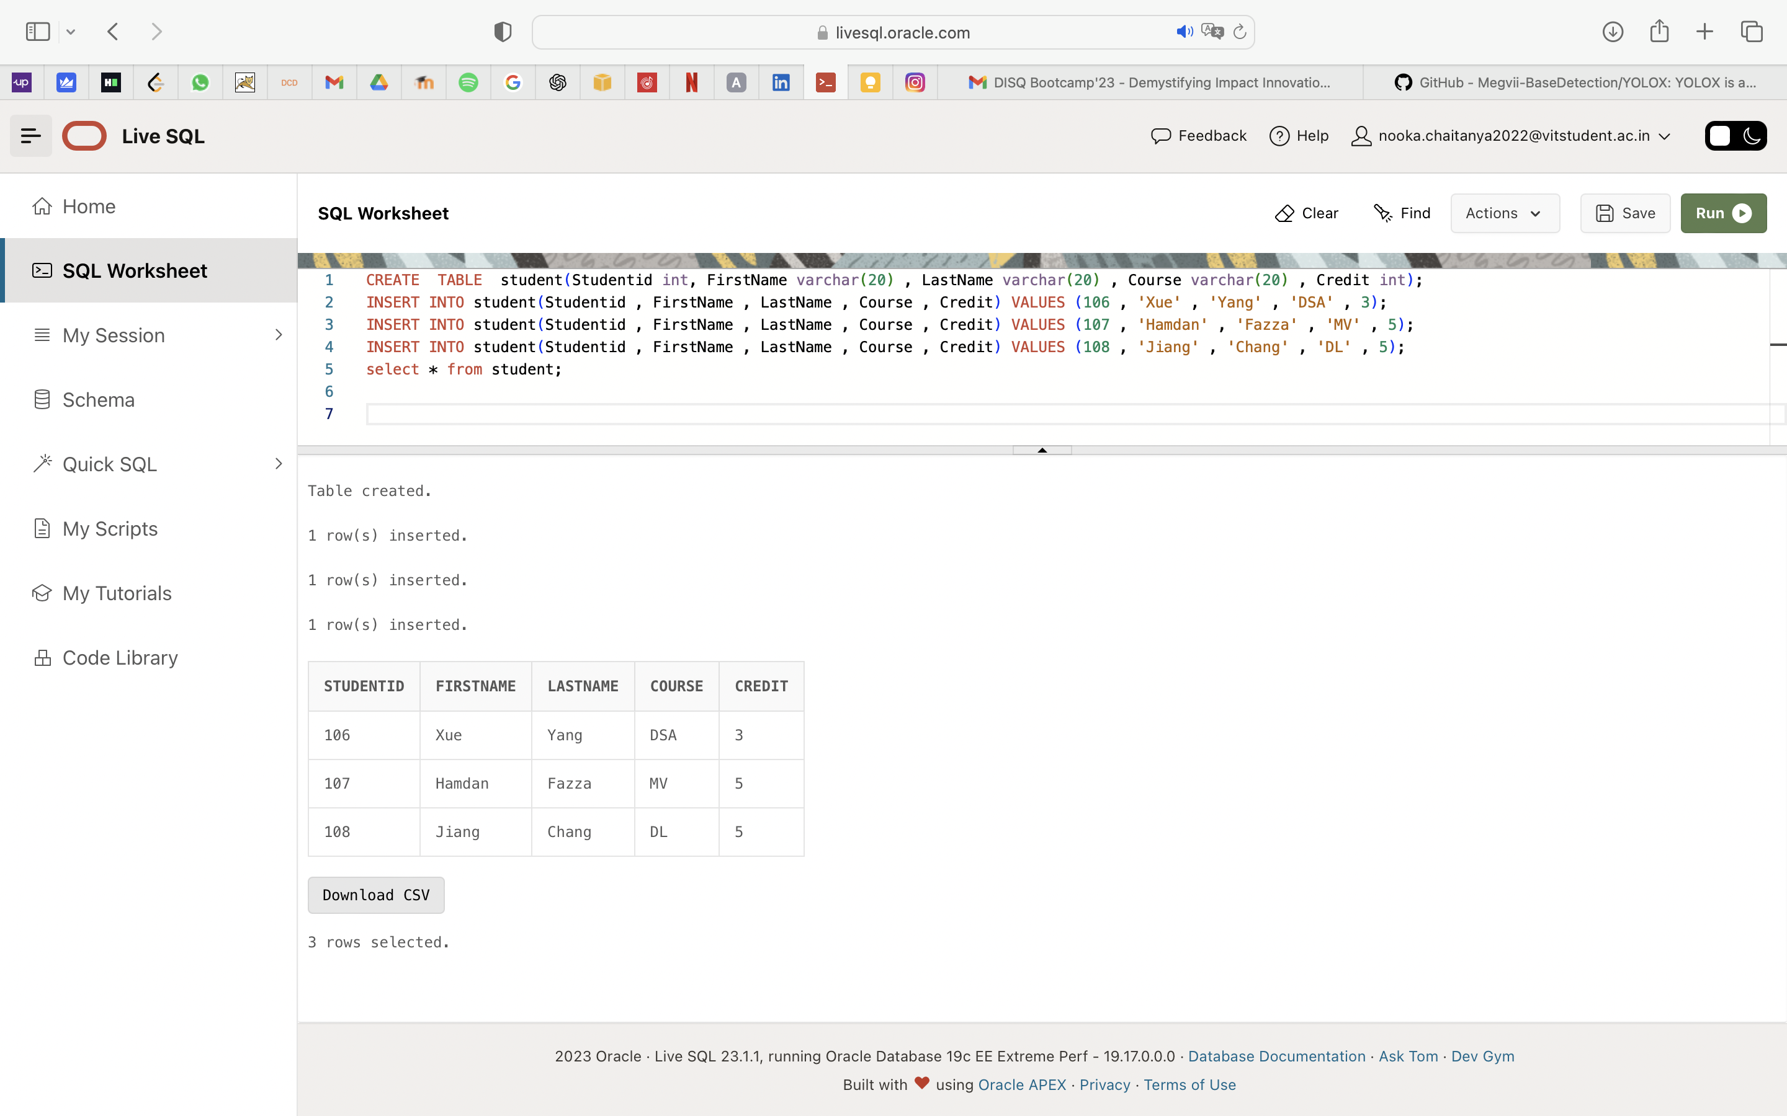

select * from student;

CREATE VIEW Students As SELECT Studentid , FirstName , LastName ,Course FROM student;

select * from Students;

UPDATE Students Set FirstName = 'Xue' where Studentid = 102;

CREATE TABLE Courses (Studentid int , Courseid varchar(20) , Marks int);

INSERT INTO Courses(Studentid , Courseid , Marks) VALUES (101 , 'CS101' , 90);

INSERT INTO Courses(Studentid , Courseid , Marks) VALUES (102 , 'CS102' , 80);

INSERT INTO Courses(Studentid , Courseid , Marks) VALUES (103 , 'CS103' , 85);

INSERT INTO Courses(Studentid , Courseid , Marks) VALUES (104 , 'CS104' , 75);

INSERT INTO Courses(Studentid , Courseid , Marks) VALUES (105 , 'CS105' , 90);

select * from Courses;

SELECT student.Studentid , student.FirstName , Courses.Marks From student INNER JOIN Courses ON student.Studentid = Courses.Studentid;

Select student.Studentid , student.FirstName , student.credit , Courses.courseid From student LEFT JOIN Courses ON student.Studentid = Courses.Studentid ORDER BY student.Credit;

Select student.Studentid , student.FirstName , student.credit , Courses.courseid From student RIGHT JOIN Courses ON student.Studentid = Courses.Studentid ORDER BY student.Credit;

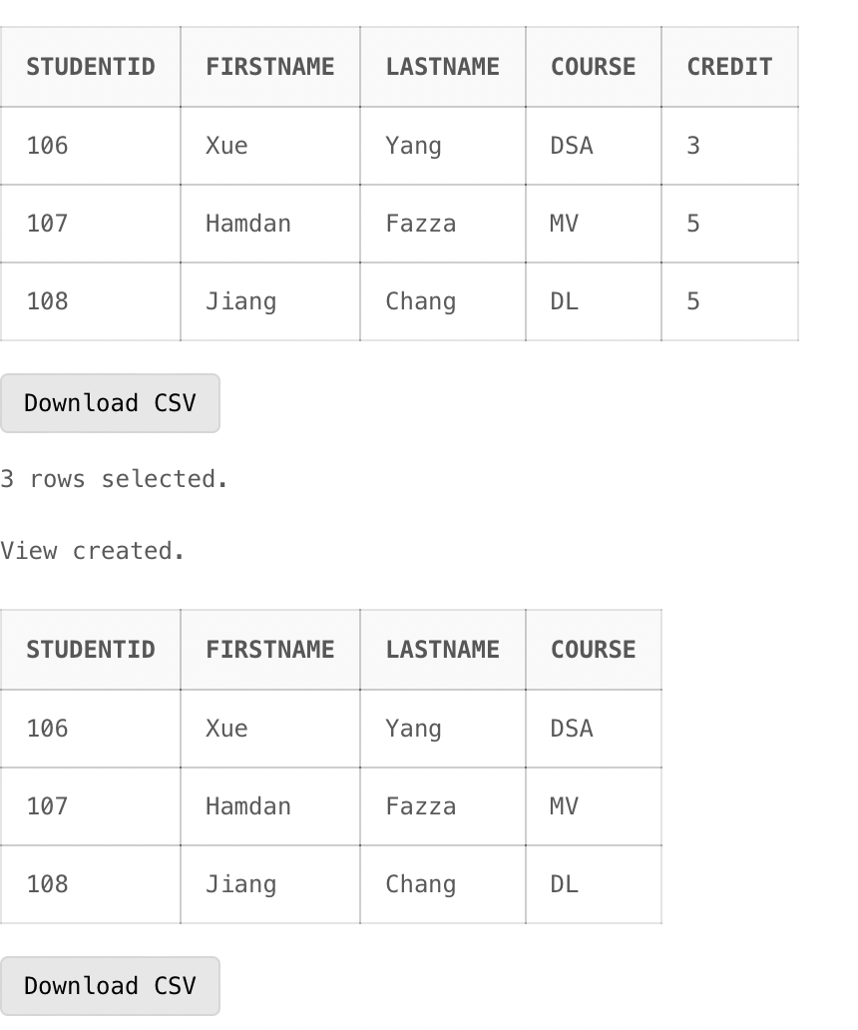

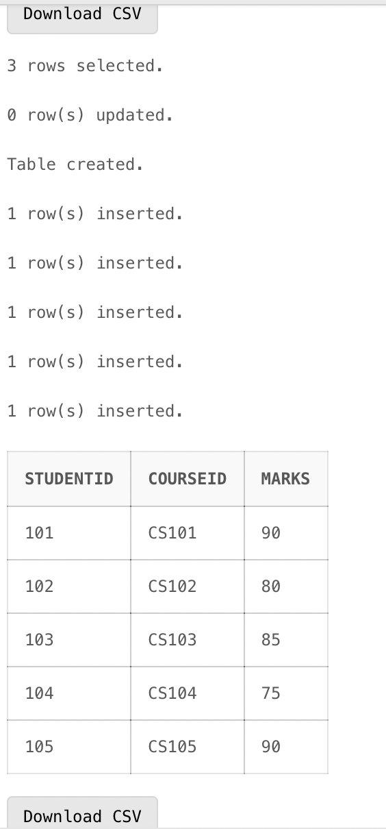

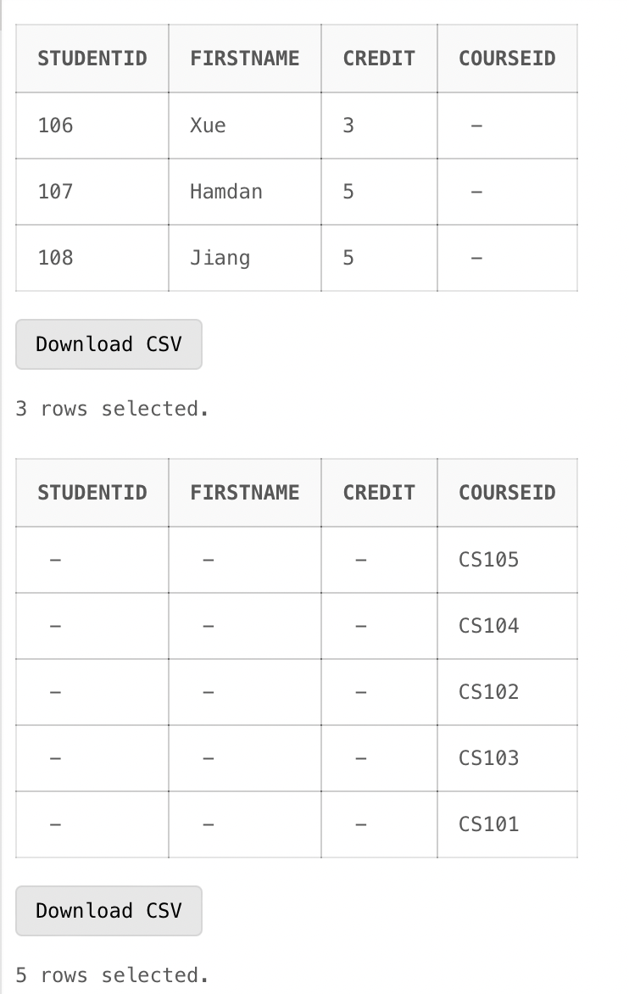

**LAB-4**

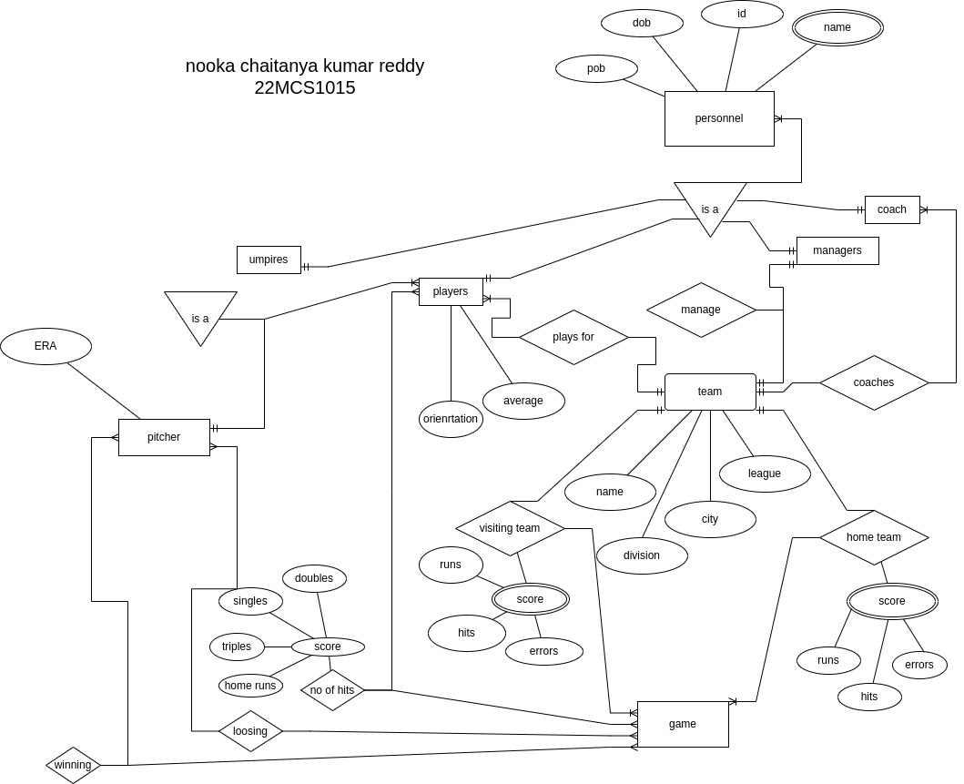

**LAB-5**

DECLARE

x number(5);

y number(5);

z number(7);

BEGIN

x:=10;

y:=20;

z:=x+y;

dbms_output.put_line('sum id '|| z);

END;

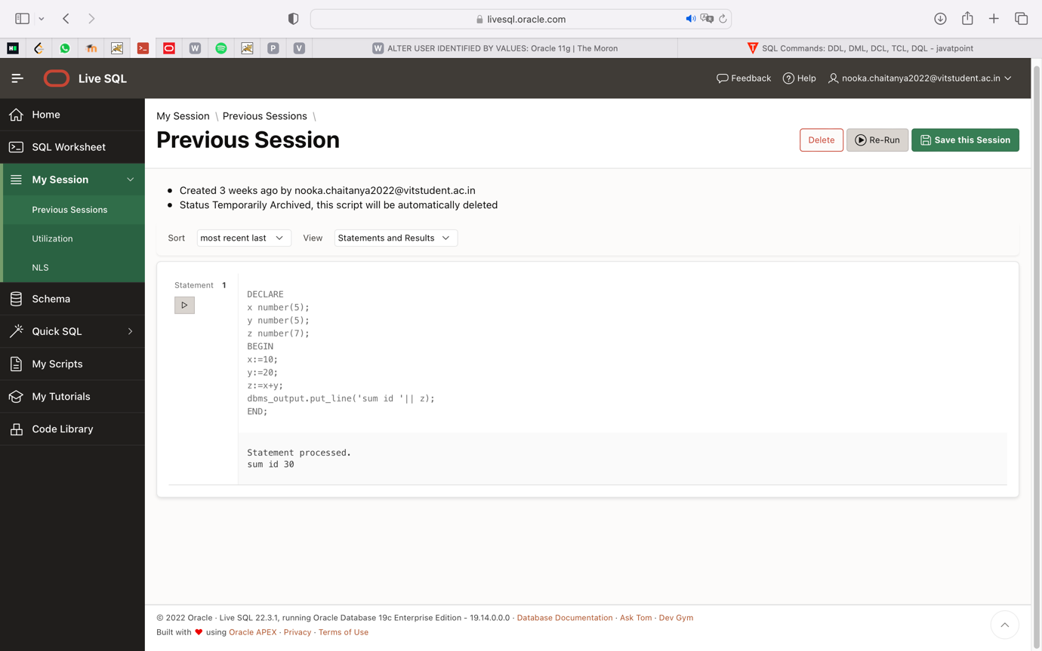

DECLARE

i number(1);

j number(1);

BEGIN

<< outer_loop >>

FOR i IN 1..3 LOOP

<< inner_loop >>

FOR j IN 1..3 LOOP

dbms_output.put_line('i is: '|| i || ' and j is: ' || j);

END loop inner_loop;

END loop outer_loop;

END;

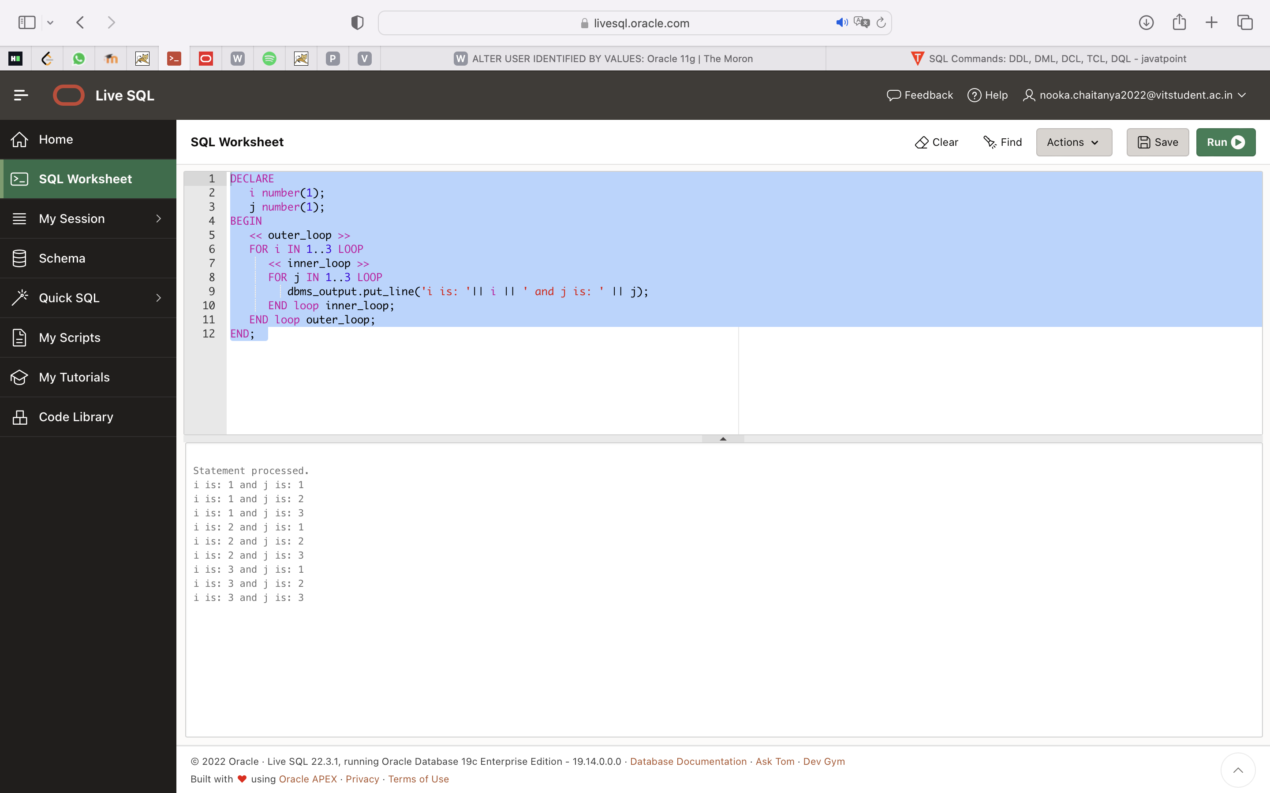

**LAB-6**

## PL SQL Cursor

**Let us consider a table which is named TUTOR.**

**We have created a table with the SQL statement given below:**

|  |
| --- |
| CREATE TABLE TUTOR(  CODE INT NOT NULL,  SUBJECT VARCHAR(15) NOT NULL,  TEACHER VARCHAR(15),  REVIEWS VARCHAR (10) NOT NULL,  PRIMARY KEY (CODE)  ); |

**Inserted values to this table with SQL statements given below:**

|  |
| --- |
| INSERT INTO TUTOR (CODE,SUBJECT,TEACHER,REVIEWS)  VALUES (1, 'Automation', 'Mukul', 'five stars');  INSERT INTO TUTOR (CODE,SUBJECT,TEACHER,REVIEWS)  VALUES (4, 'PLSQL', 'Anand', 'four stars');  INSERT INTO TUTOR (CODE,SUBJECT,TEACHER,REVIEWS)  VALUES (2, 'Performance', 'Arvind', 'four stars'); |

SELECT * FROM TUTOR;

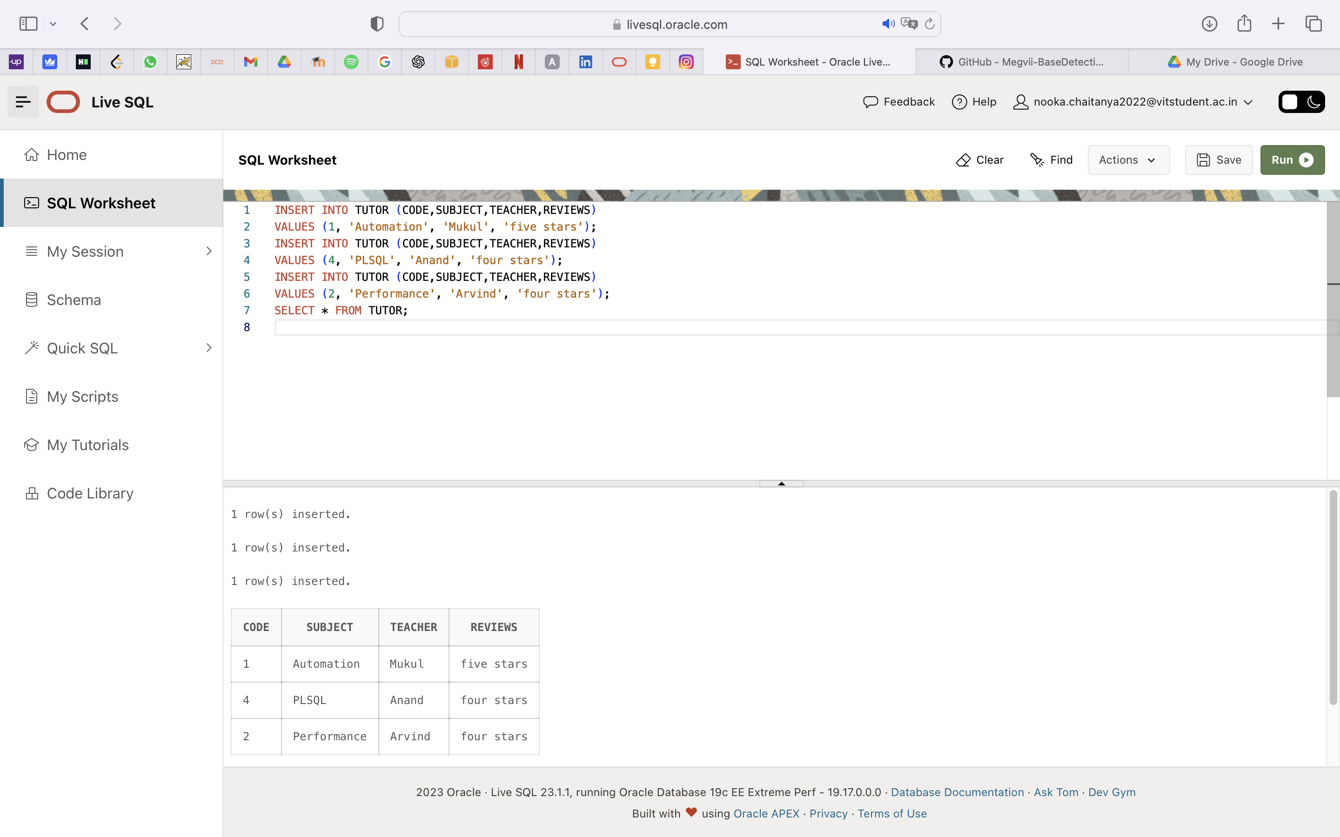

**Code implementation with the implicit cursor:**

|  |  |  |  |
| --- | --- | --- | --- |
| DECLARE      total_count number(30);  BEGIN      --updating a row      UPDATE TUTOR      SET TEACHER = 'Zen' where CODE = 1;       -- result in boolean, true returned if no rows affected      IF sql%notfound THEN          dbms_output.put_line('no subjects fetched');          -- result in boolean, true returned if any rows affected          ELSIF sql%found THEN          -- count the number of rows affected rows affected          total_count := sql%rowcount;          dbms_output.put_line( total_count || ' teacher name updated ');      END IF;  END;  /  **The output of the above code should be:**    Let us now verify the changes reflected in the table named TUTOR.  **We are using a SQL statement to get the columns of the table:**  SELECT * FROM TUTOR;   Explicit Cursors The developers can have their own user-defined context area to run DML operations. Thus they can exercise more power over it. The declaration section of the PL/SQL block of code contains explicit cursors. It is normally built on SELECT operations that fetch multiple rows.  **Syntax of explicit cursor:**  DECLARE  CURSOR <<cursor name>> IS <<select statement>>  <<Cursor variable>>  BEGIN  OPEN <<cursor name>>;  FETCH <<cursor name>> INTO <Cursor variable>  CLOSE <cursor name>;  END;  **Explicit Cursor works on the processes listed below:**  **#1)** **Cursor declaration for memory initialization.**  Here, a named context area is created which serves as a cursor name.  **Syntax:**  CURSOR tutorial_s IS  SELECT code FROM TUTORIAL;    **#2)** **Cursor opening for memory allocation**.  A cursor is now available for fetching the updated rows from the database.  **Syntax:**  OPEN tutorial_s;  **#3) Cursor is fetched for getting the data.**  After the SELECT operation is done, the rows obtained are put in the memory allocated and these are now considered as active sets. The cursor can access one row at a time.  **Syntax:**  FETCH tutorial_s INTO c_code;  **#4) Cursor is finally closed to free the allocated memory.**  As all the records are obtained one by one, the cursor is closed to release context area memory.  **Syntax:**  CLOSE tutorial_s;  **Code implementation with explicit cursor:**   |  | | --- | | DECLARE     -- cursor declaration  CURSOR t_tutorials is  SELECT code, subject, teacher FROM Tutor;  t_code Tutor.code%type;  t_subject Tutor.subject%type;  t_teacher Tutor.teacher%type;  BEGIN       -- opening a cursor     OPEN t_tutorials;  LOOP        -- fetching values from cursor      FETCH t_tutorials into t_code, t_subject, t_teacher;      EXIT WHEN t_tutorials%notfound;        -- printing in console      dbms_output.put_line('Code is: ' || t_code || ' ' || 'Subject is: ' || t_subject || ' Teacher is: ' || t_teacher);  END LOOP;  CLOSE t_tutorials;  END;  / |   **The output of the above code should be:**   Triggers In PL/SQL:Create Triggers **The syntax for creating a trigger:**   |  | | --- | | CREATE [OR REPLACE ] TRIGGER trigger_n  {BEFORE | AFTER | INSTEAD OF }  {INSERT [OR] | UPDATE [OR] | DELETE}  [OF column_n]  ON table_n  [REFERENCING OLD AS o NEW AS n]  [FOR EACH ROW]  WHEN (condition)  DECLARE      << Declaration statement >>  BEGIN     << Block of executable code>>  EXCEPTION     << Exception handling if any >>    END; |   **Code Implementation for trigger creation:**   |  | | --- | | CREATE OR REPLACE TRIGGER age_changes  BEFORE DELETE OR INSERT OR UPDATE ON student  FOR EACH ROW  WHEN (NEW.CODE > 0)  DECLARE     age_diff number;  BEGIN     age_diff := :NEW.age  - :OLD.age;     dbms_output.put_line ('Prevoius age: ' || : OLD.age);     dbms_output.put_line ('Current age: ' || : NEW.age);     dbms_output.put_line ('Age difference: ' || age_diff);  END;  / |   **Output of the above code:**  [Create Triggers](https://www.softwaretestinghelp.com/wp-content/qa/uploads/2020/09/PLSQL-Tutorial-Series-Part10-1.png) |

**LAB-7**

**SQL Builtin Functions and write a program that works with PL/SQL Functions**

CREATE TABLE customer(ID number NOT NULL,name varchar(20) NOT NULL, address varchar(20),Age int,salary number,PRIMARY KEY (ID));

Desc customer;

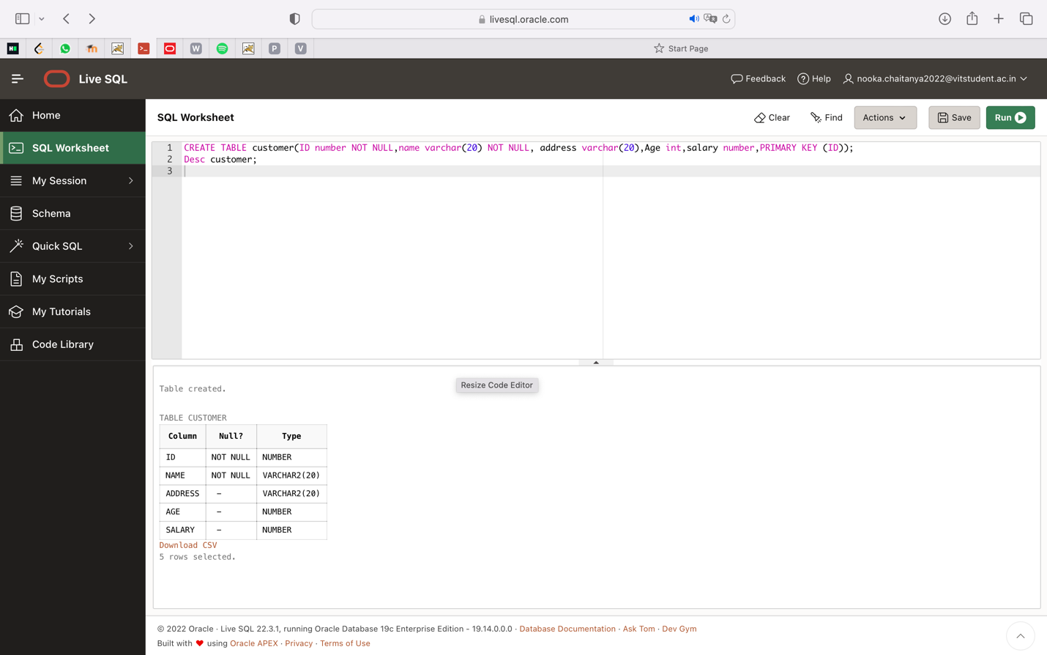

insert into customer values (1, 'chaitanya', 'chennai',20, 100000);

insert into customer values (2, 'queen', 'kanpur',22,100000);

insert into customer values (3, 'king', 'chennai',20,100000);

select * from customer;

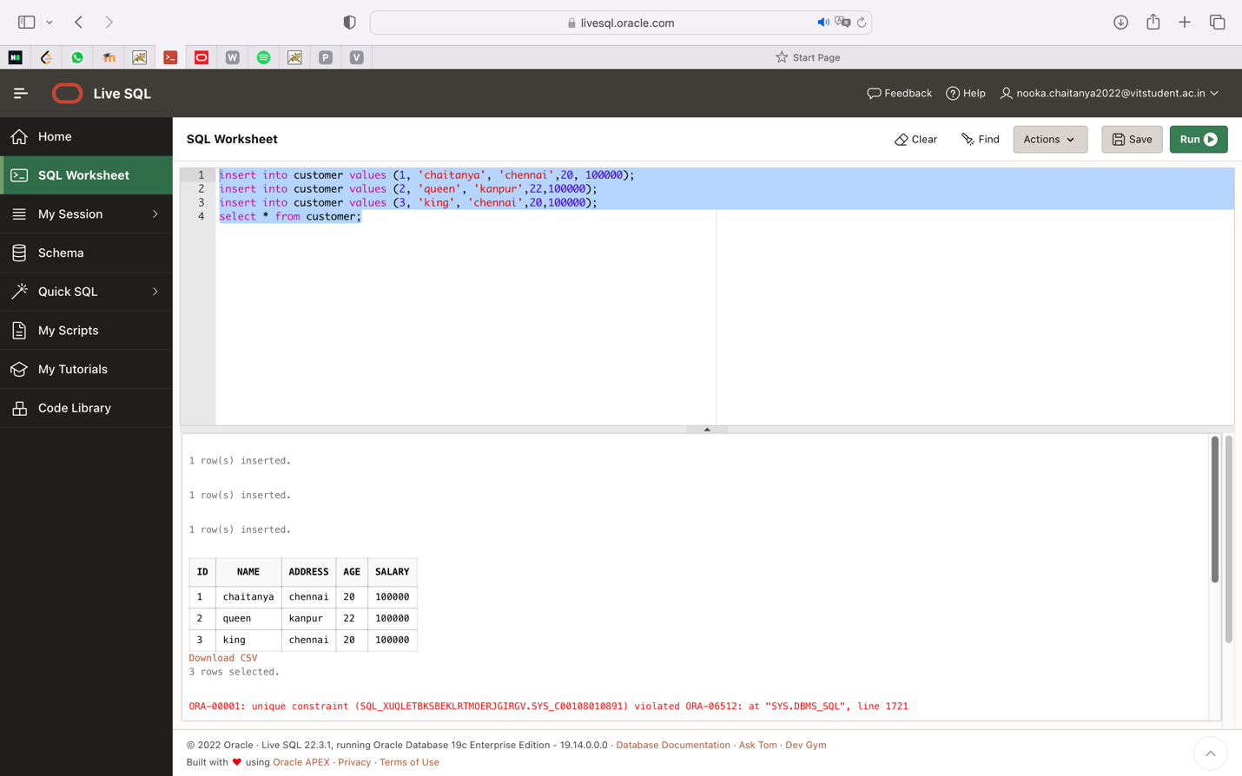

**SQL BUILD IN FUNCTION**

select avg(salary) from customer;

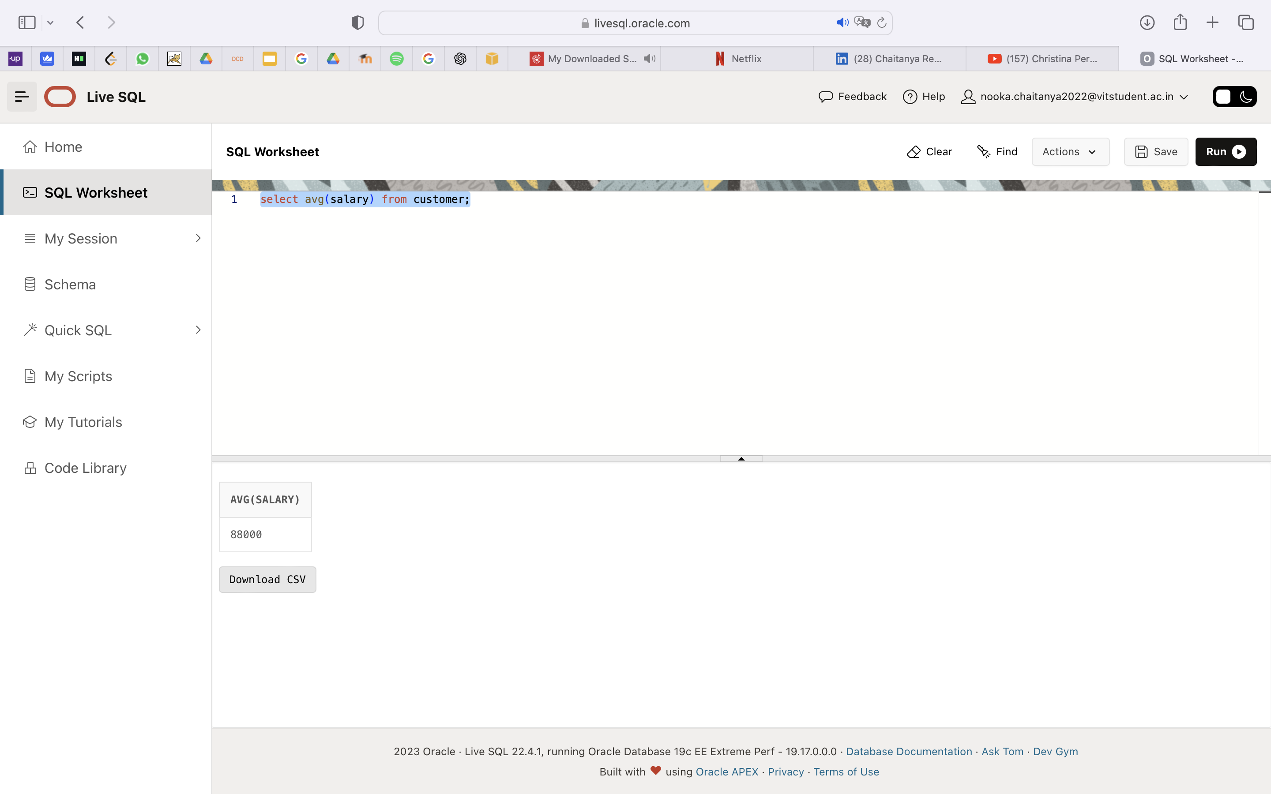

select min(salary) from customer;

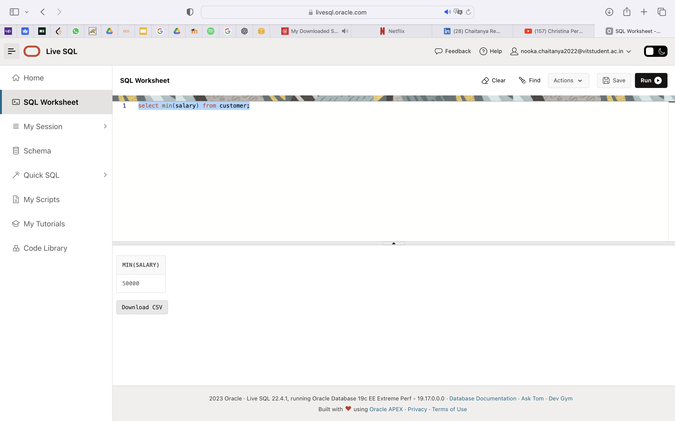

select max(salary) from customer;

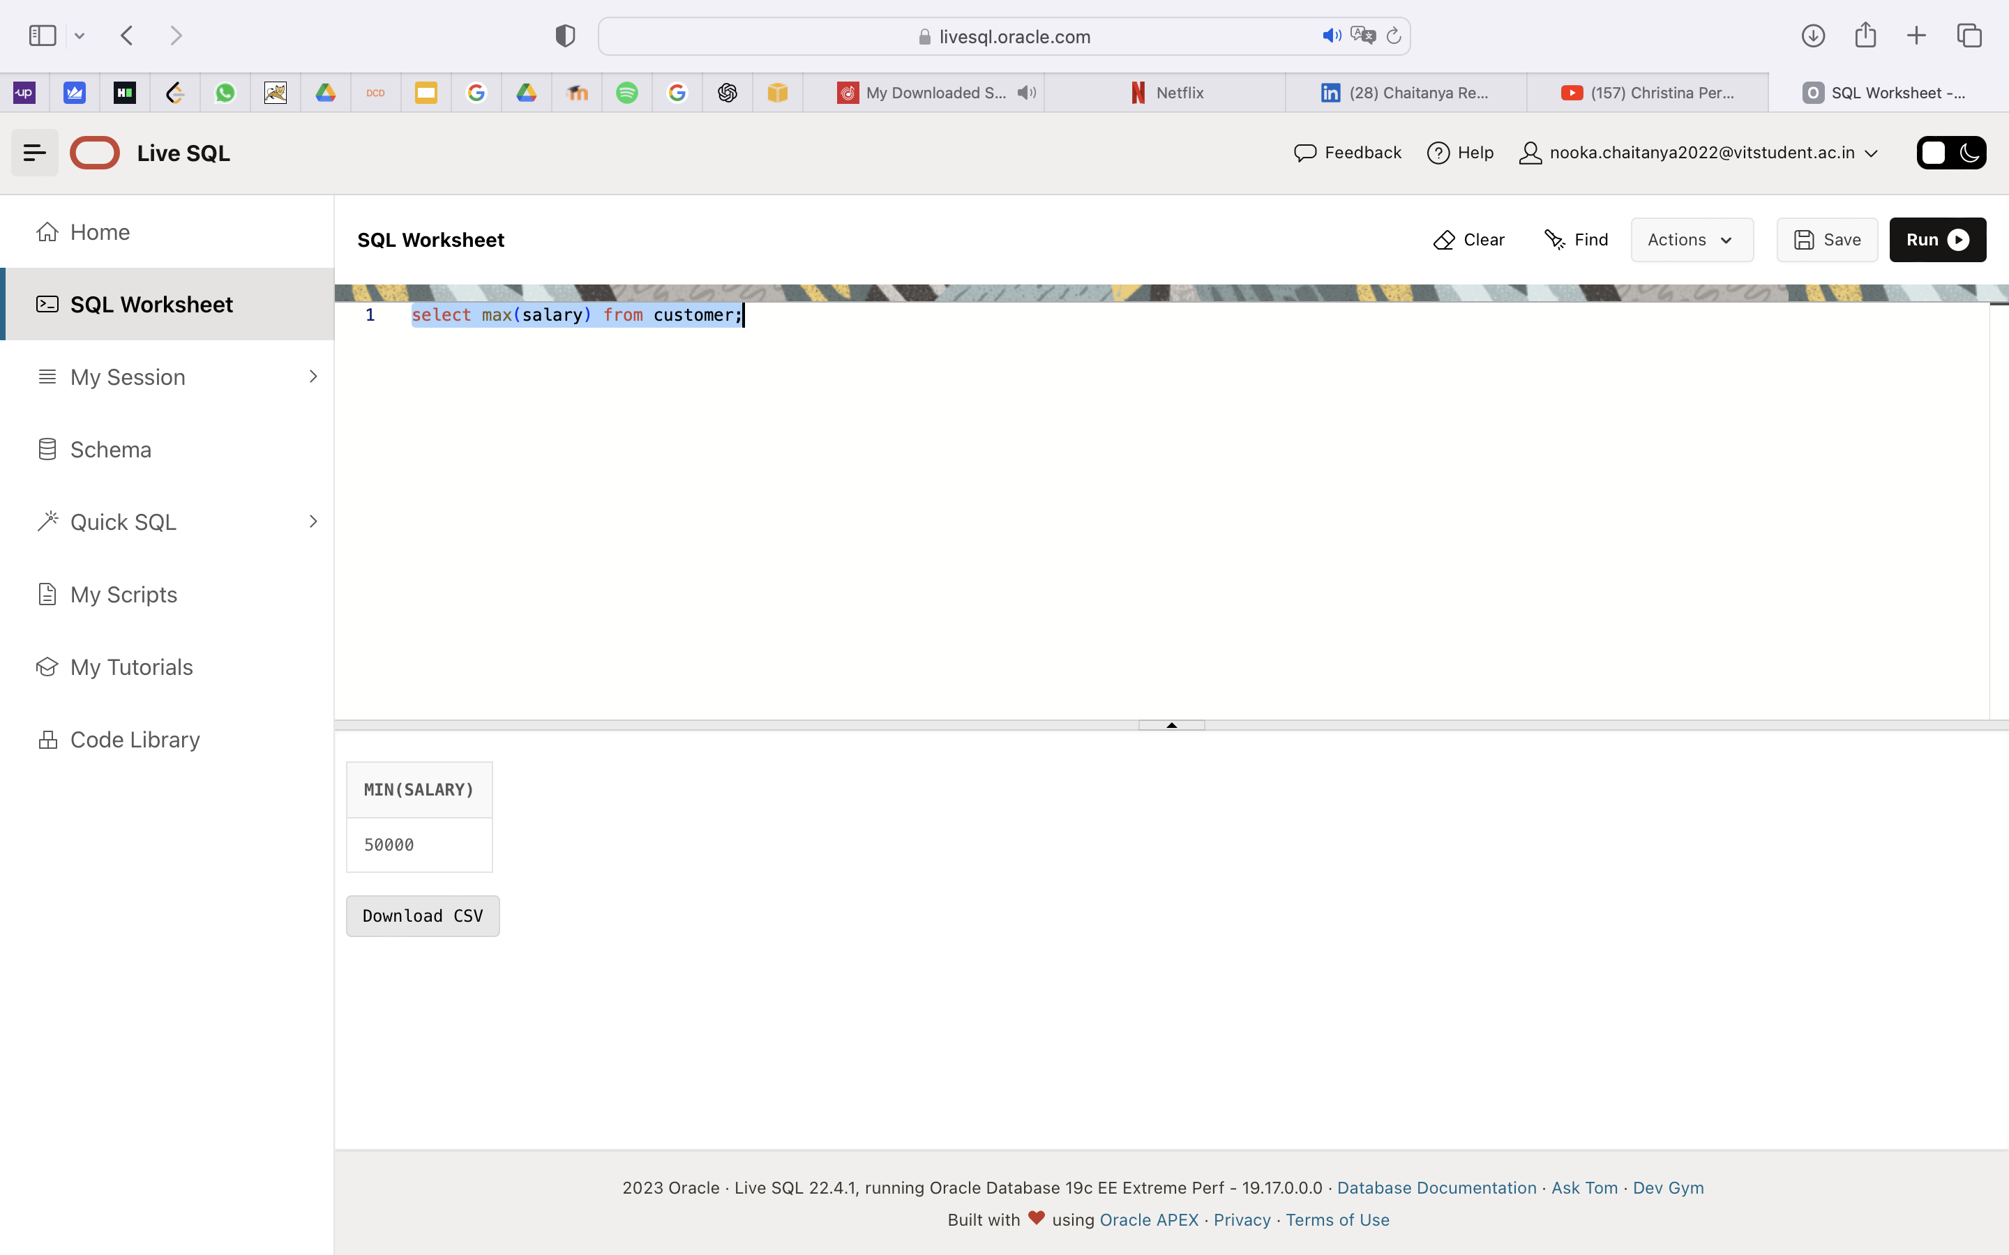

**PLSQL FUNCTION**

CREATE OR REPLACE FUNCTION totalCustomers

RETURN number IS

total number(2) := 0;

BEGIN

SELECT count(*) into total

FROM customer;

RETURN total;

END;

/

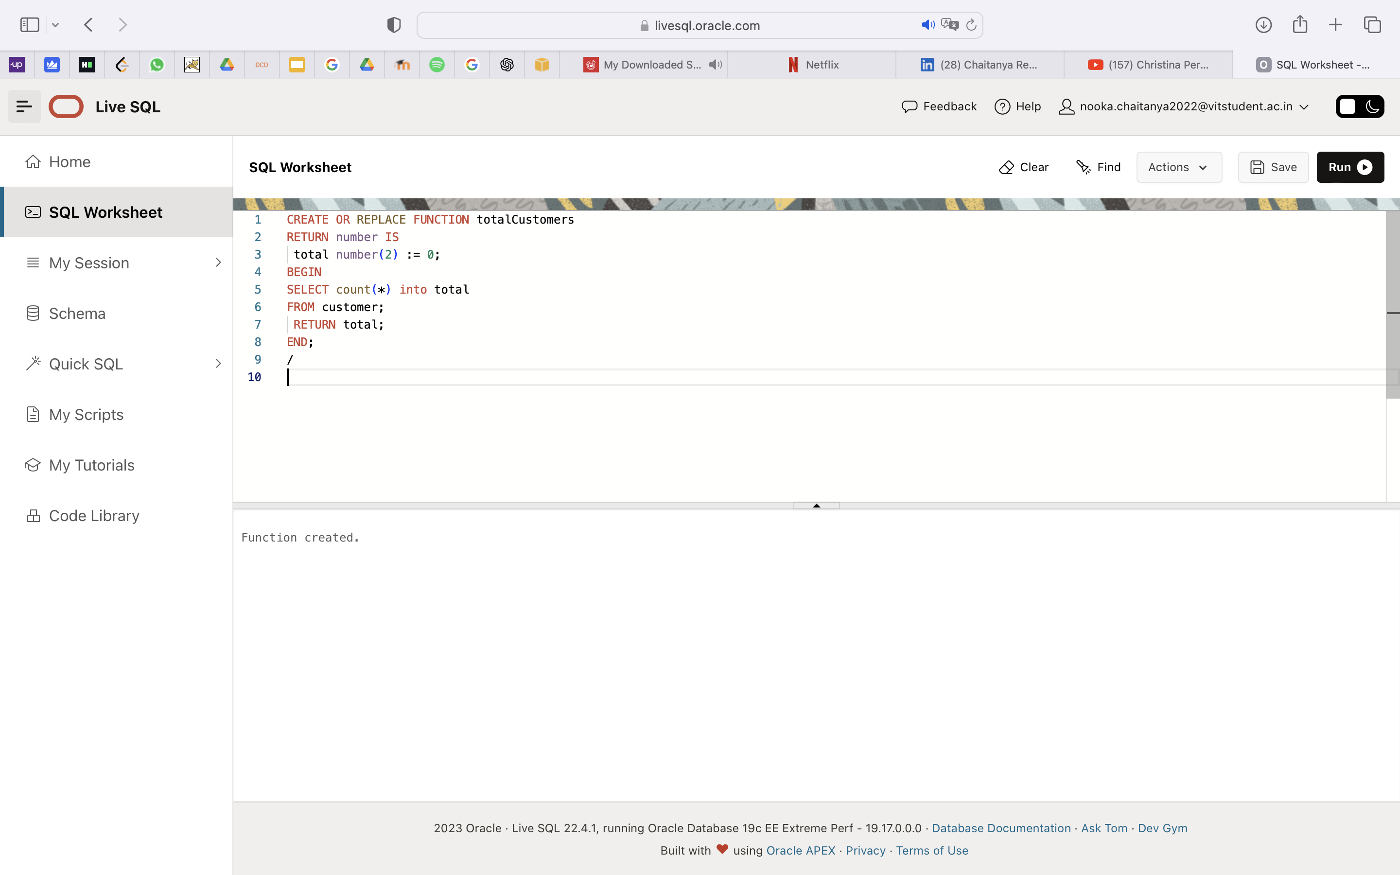

DECLARE

c number(2);

BEGIN

c := total Customers();

dbms_output.put_line('Total no. of Customers: ' || c);

END;

/

Output:

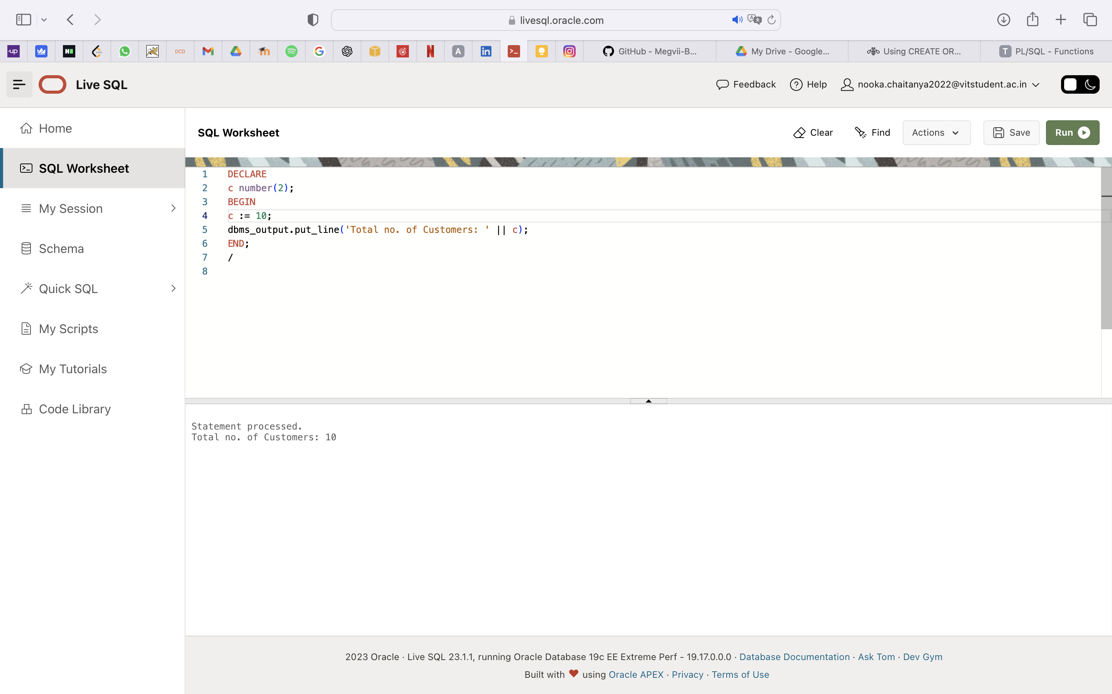

DECLARE

a number;

b number;

c number;

FUNCTION findMax(x IN number, y IN number)

RETURN number

IS

z number;

BEGIN

IF x > y THEN

z:= x;

ELSE

Z:= y;

END IF;

RETURN z;

END;

BEGIN

a:= 23;

b:= 45;

c := findMax(a, b);

dbms_output.put_line(' Maximum of (23,45): ' || c);

END;

/

Output:

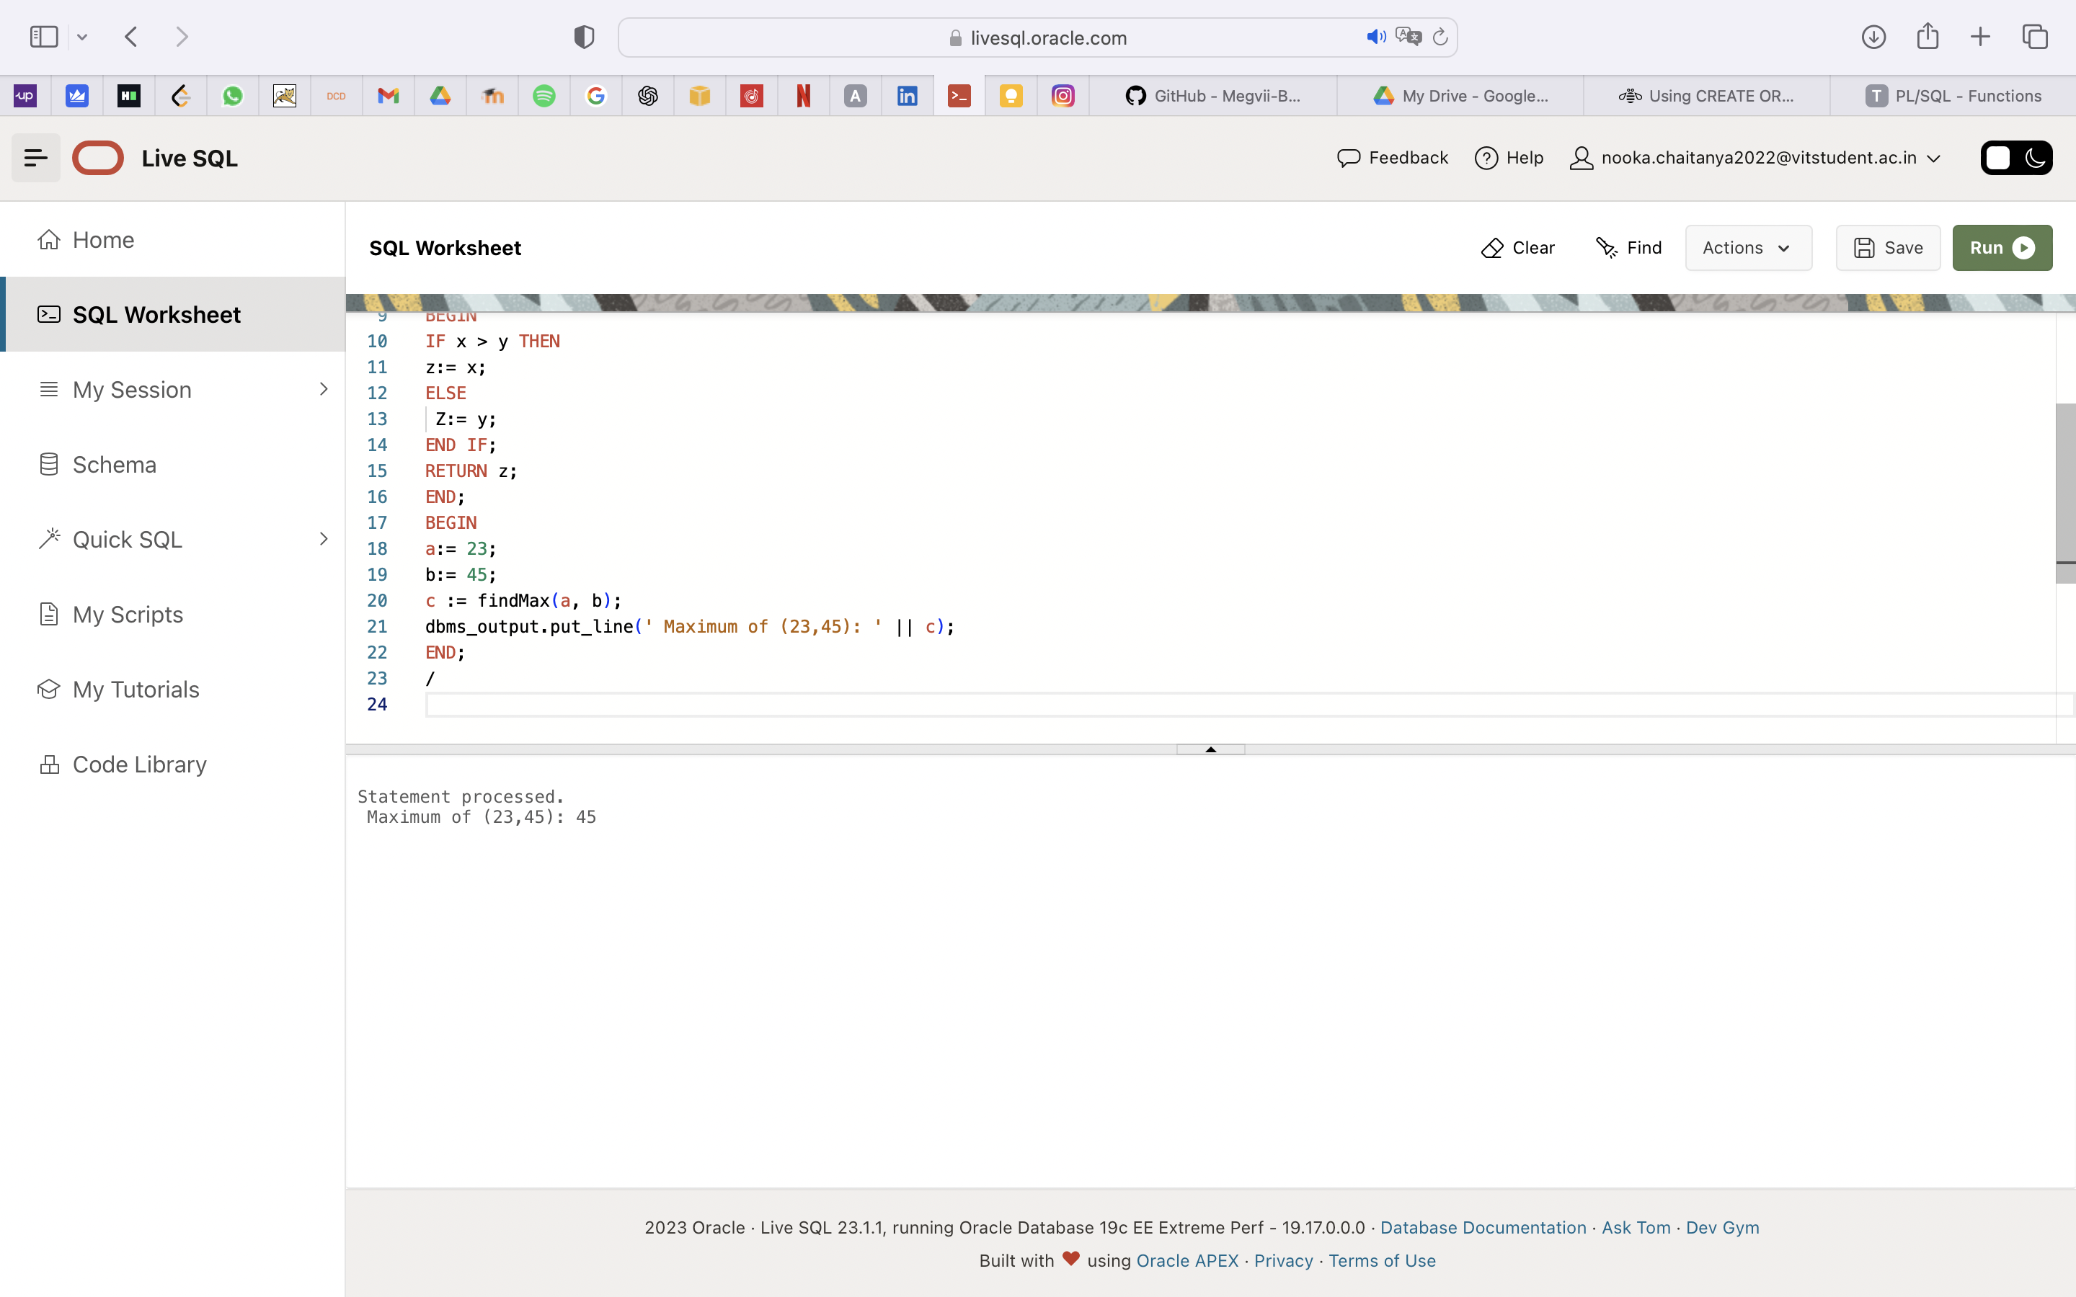

**LAB-8**

Select column to map the geography

Go to data

Select the geography

Click on the cell. It will show table symbol on right.

Click on the table symbol

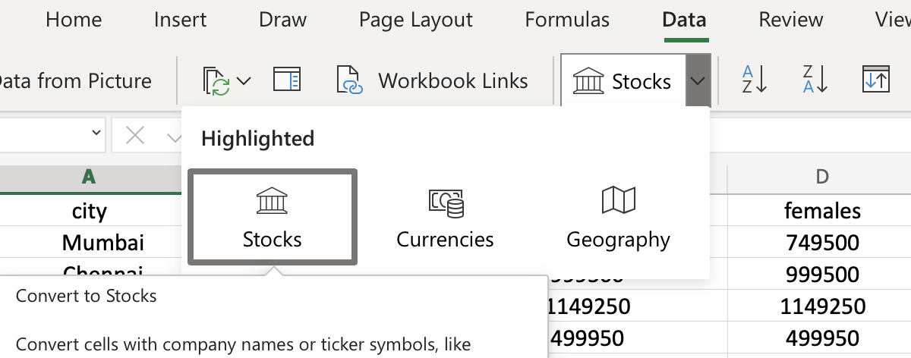

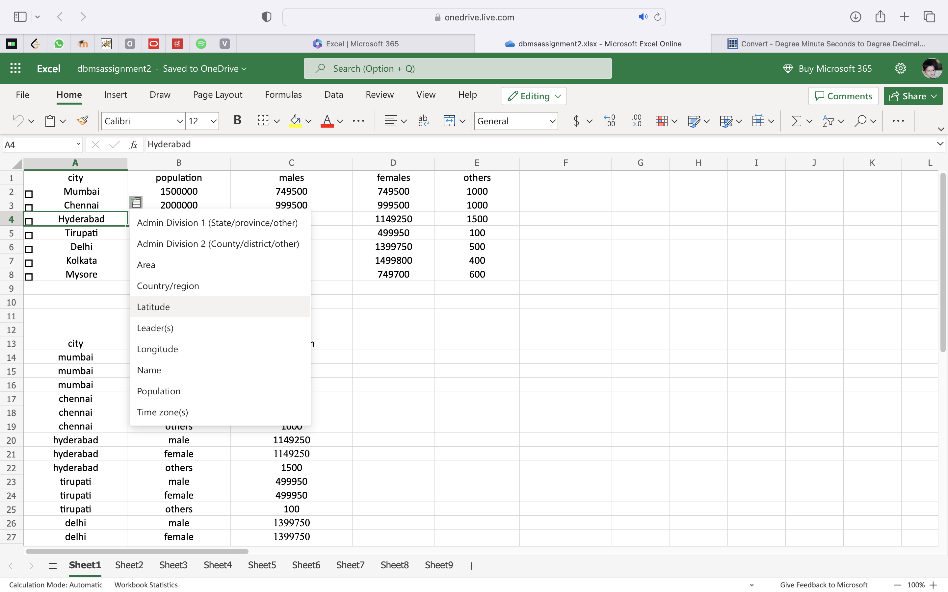

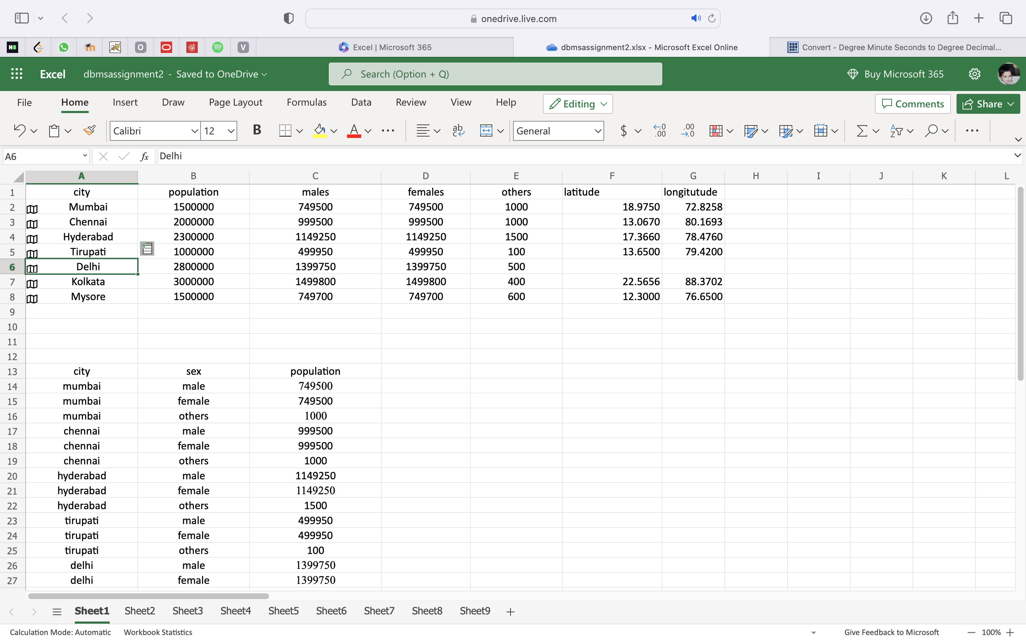

**Convert Degree Minute Seconds to Degree Decimal for the Latitude Longitude values:**

As 1°=60’=3600”, so we can compute degree decimal by:

**d = degree + minute / 60 + seconds/3600**

Let us take an **example**: Compute 29° 25′ 26.5152″, -98° 29′ 37.6974″ to degree decimal:

Latitude to Degree Decimal = d = 29 + 25/60 + 26.5152/3600 = 29.42432  
Longitude to Degree Decimal = d = -(98 + 29/60 + 37.6974/3600) = -98.493805

**LAB-9**

**Define a Relational Table Containing No ORDAudio Object**

create table flat (

id NUMBER,

description VARCHAR2(4000),

localData BLOB,

srcType VARCHAR2(4000),

srcLocation VARCHAR2(4000),

srcName VARCHAR2(4000),

upDateTime DATE,

local NUMBER,

format VARCHAR2(31),

mimeType VARCHAR2(4000),

comments CLOB,

encoding VARCHAR2(256),

numberOfChannels NUMBER,

samplingRate NUMBER,

sampleSize NUMBER,

compressionType VARCHAR2(4000),

audioDuration NUMBER,

)

--

-- Store audio data as SecureFiles LOBs.

--

LOB(localData) STORE AS SECUREFILE;

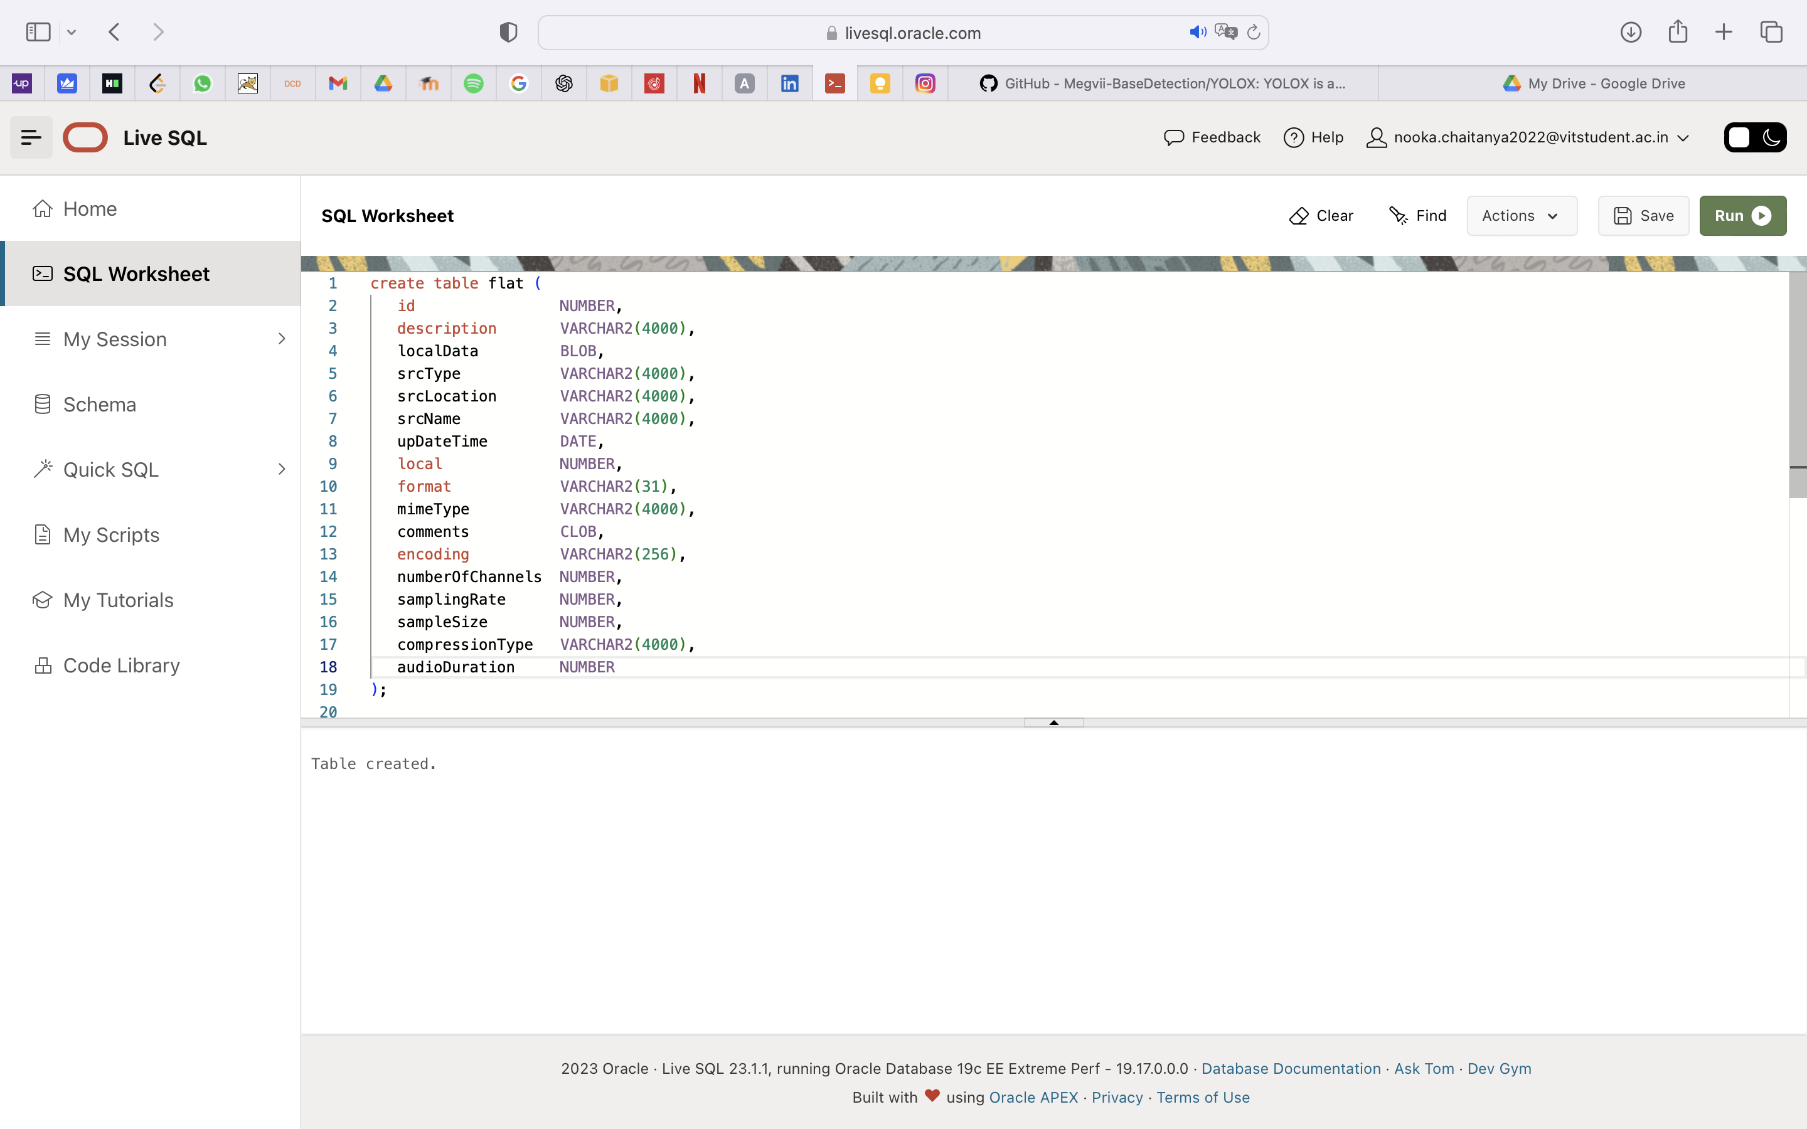

**Define an Object View Containing an ORDAudio Object and Relational Columns**

create or replace view object_audio_v as

select

id,

ORDSYS.ORDAudio(T.description,

ORDSYS.ORDSource(

T.localData, T.srctype, T.srcLocation, T.srcName, T.updateTime,

T.local),

T.format,

T.mimeType,

T.comments,

T.encoding,

T.numberOfChannels,

T.samplingRate,

T.sampleSize,

T.compressionType,

T.audioDuration)

from flat T;

**create_mediadir.sql Script**

-- create_mediadir.sql

--

SET SERVEROUTPUT ON;

SET ECHO ON;

-- To delete the directory, uncomment the next statement;

-- otherwise, leave it commented out.

-- DROP DIRECTORY media_dir;

-- To specify a different directory path, replace the default directory

-- path with the new path in the next statement.

CREATE OR REPLACE DIRECTORY media_dir AS 'C:\media_dir';

-- To change the user, uncomment the next statement and replace the

-- string "<USER>" with the new user. Otherwise, leave the statement

-- commented out.

-- GRANT READ ON DIRECTORY media_dir TO <USER>;

**create_soundtable.sql Script**

-- create_soundtable.sql

--

-- Create the soundtable table. This table is used ONLY to show

-- how to copy data from a BLOB column to an ORDAudio column.

--

-- Insert a row into the table with an empty BLOB.

-- Load the row with BLOB data by pointing to the audio file to

-- be loaded from the directory specified using the BFILE data

-- type.

-- Close the files and commit the transaction.

-- Check the length of the BLOB loaded. Is the length

-- what you are expecting?

--

SET SERVEROUTPUT ON;

CREATE TABLE soundtable ( id number,

sound BLOB default EMPTY_BLOB() )

--

-- Store audio data as SecureFiles LOBs.

--

LOB(sound) STORE AS SECUREFILE;

--

INSERT INTO soundtable(id, sound) VALUES (1, EMPTY_BLOB());

COMMIT;

DECLARE

f_lob BFILE := BFILENAME('MEDIA_DIR','aud1.wav');

b_lob BLOB;

length INTEGER;

BEGIN

SELECT sound INTO b_lob FROM soundtable WHERE id=1 FOR UPDATE;

-- Open the LOBs.

dbms_lob.open(f_lob, dbms_lob.file_readonly);

dbms_lob.open(b_lob, dbms_lob.lob_readwrite);

-- Populate the BLOB from the 'aud1.wav' file in the BFILE.

dbms_lob.loadfromfile (b_lob, f_lob, dbms_lob.getlength(f_lob));

-- Close the LOBs.

dbms_lob.close(b_lob);

dbms_lob.close(f_lob);

COMMIT;

-- Check the length of the LOB.

SELECT dbms_lob.getlength(t.sound) INTO length FROM soundtable t WHERE id = 1;

DBMS_OUTPUT.PUT_LINE('The length is '|| length);

END;

/

**LAB-10**

Create a Multimedia table using Multimedia datatype for Images and Video

CREATE TABLE multimedia (

id1 INTEGER PRIMARY KEY,

file_name VARCHAR(255) NOT NULL,

file_type VARCHAR(255) NOT NULL,

file1 BLOB NOT NULL,

uploaded_at DATE DEFAULT CURRENT_TIMESTAMP

)

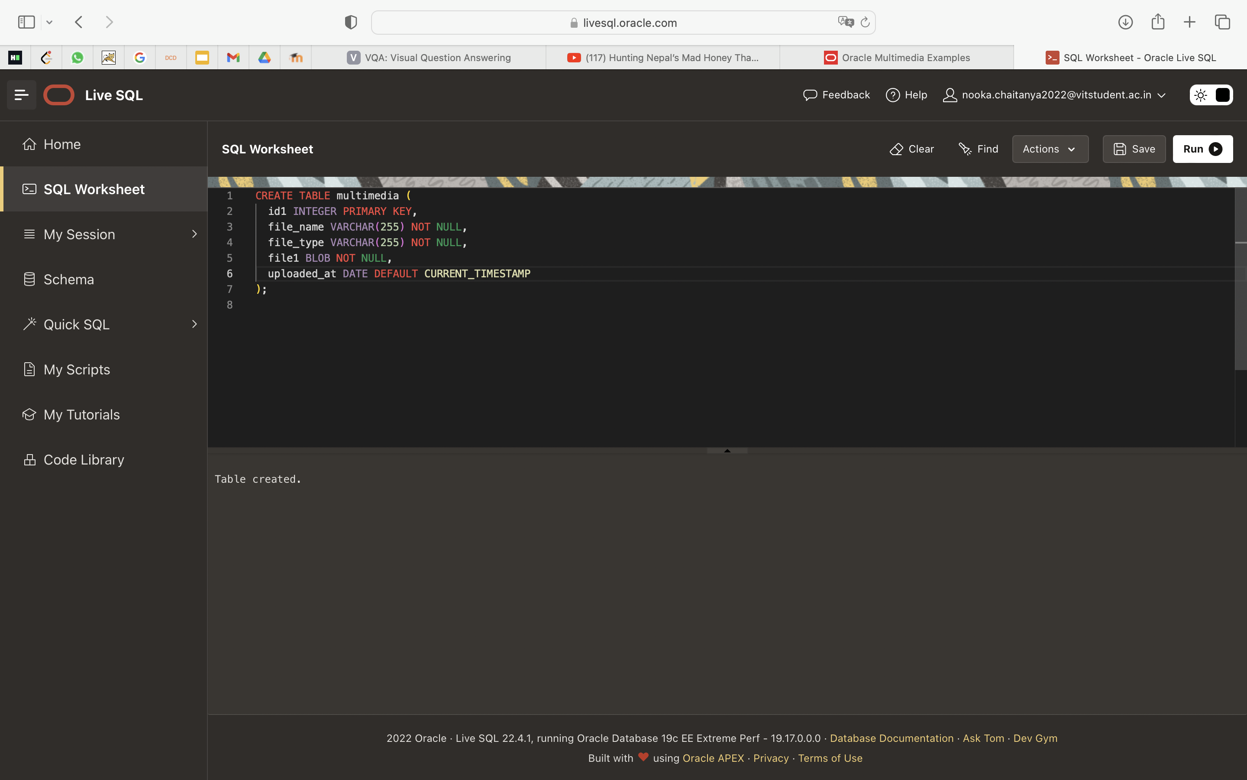

Use Search and Filter Options

SELECT * FROM multimedia WHERE file_type='image/jpeg';

SELECT * FROM multimedia WHERE file_name LIKE '%sunset%';

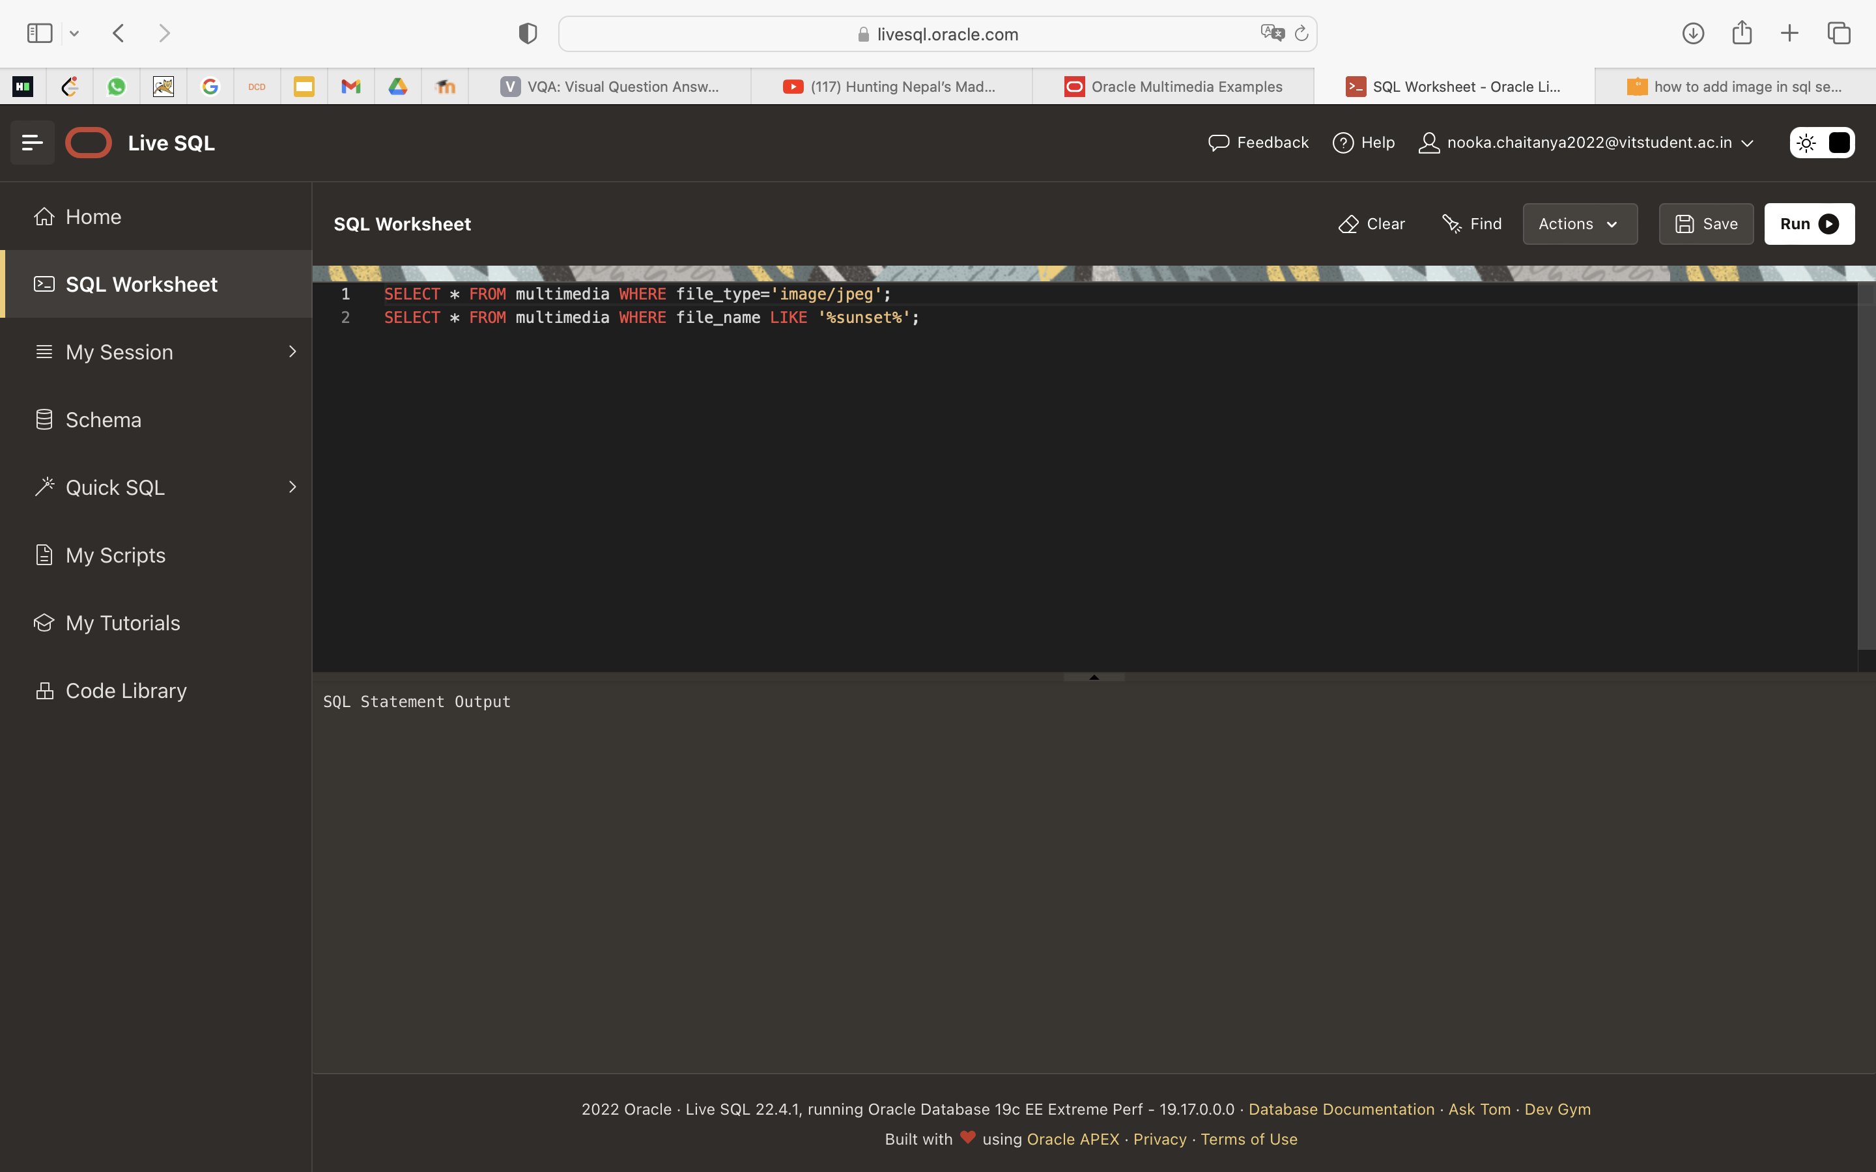

**LAB-11**

**After opening the new file**

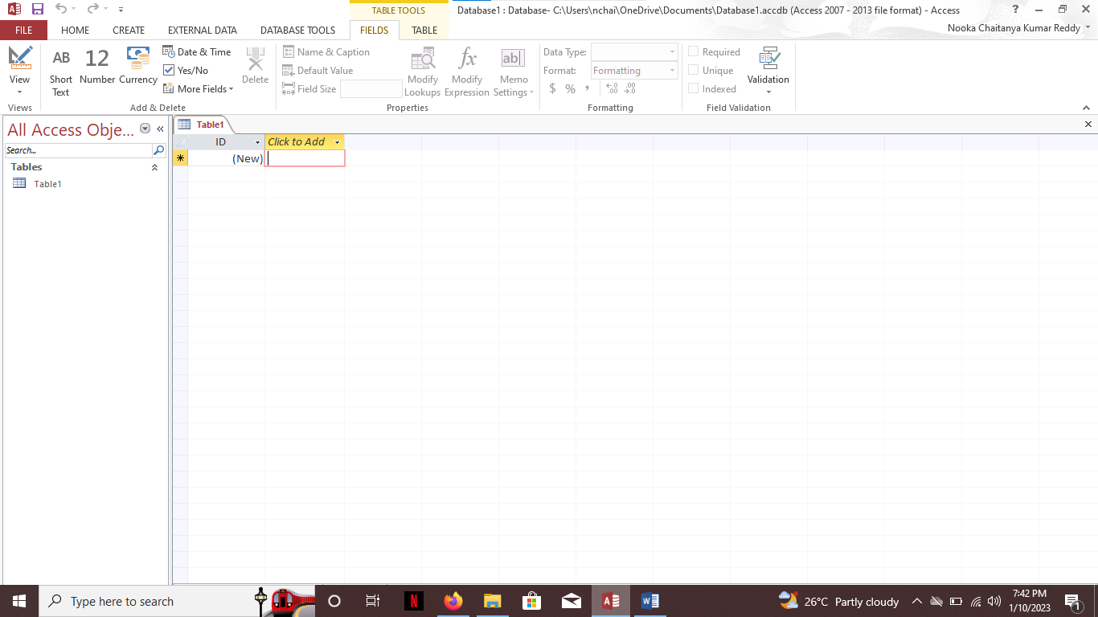

**Enter the values in table**

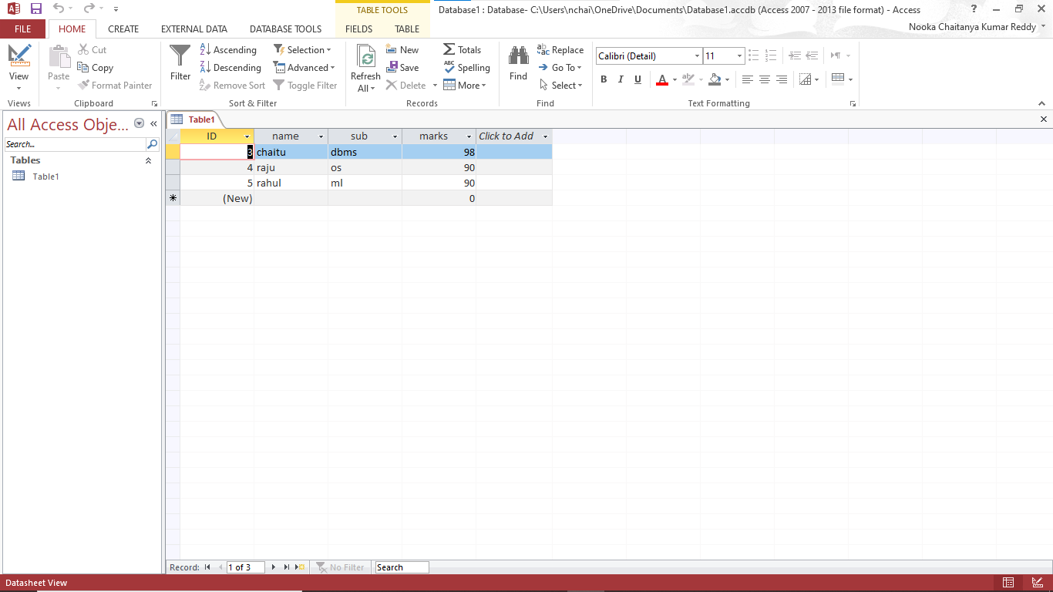

**Go to view and select design view to see the data types**

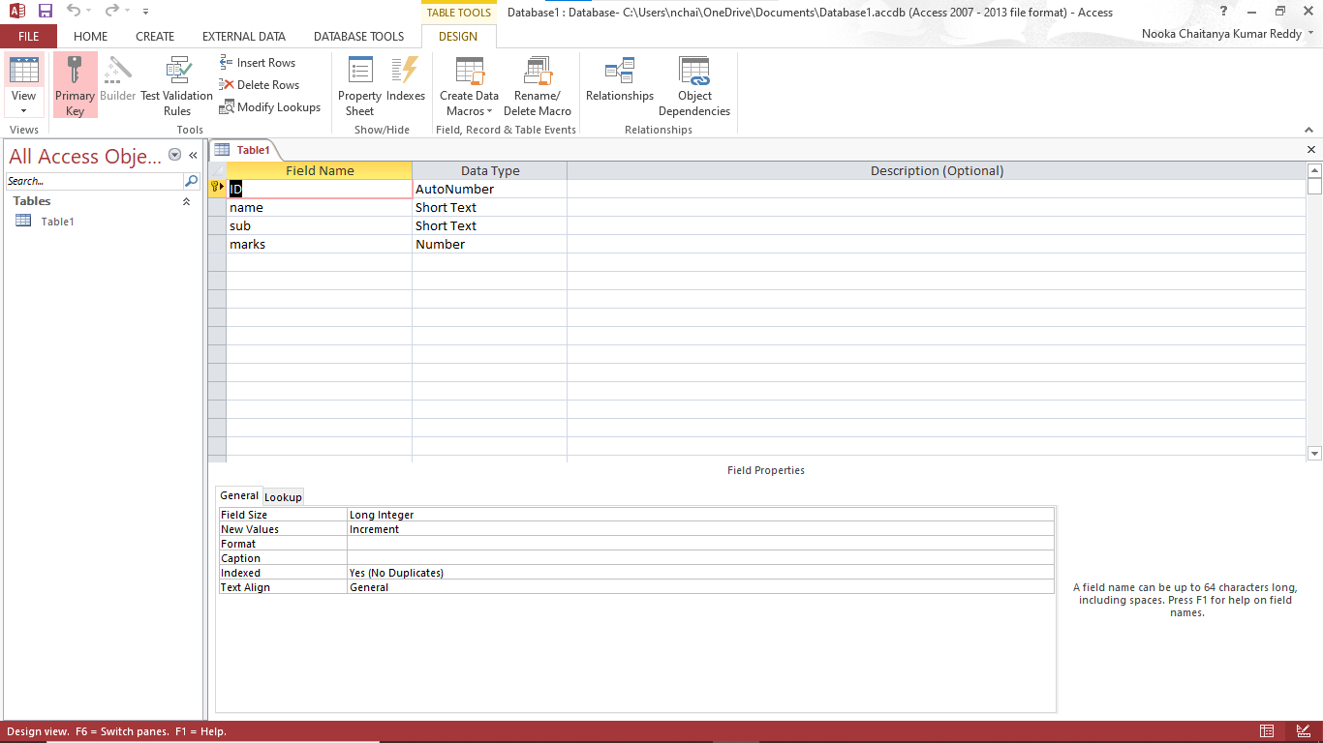

**Goto create and select query wizard**

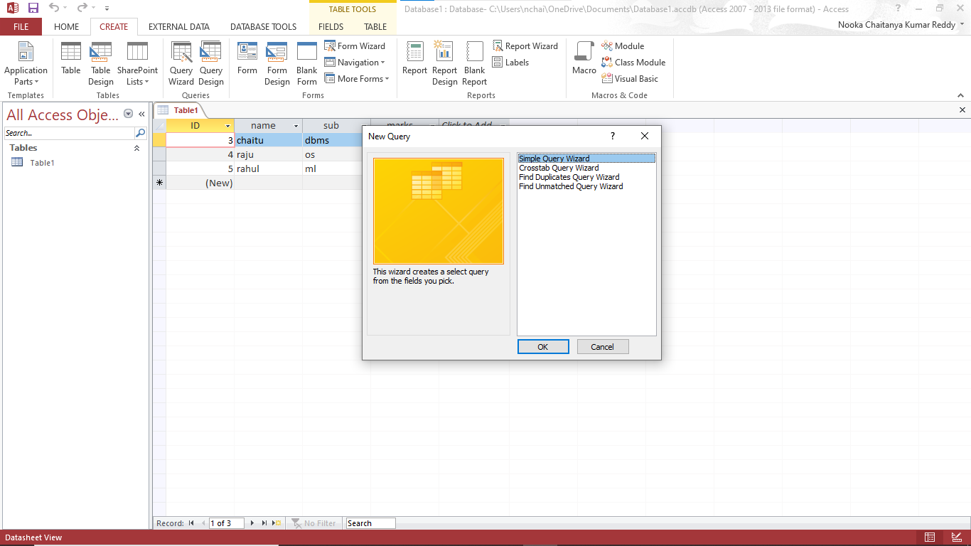

**Click on simple query wizard and press ok**

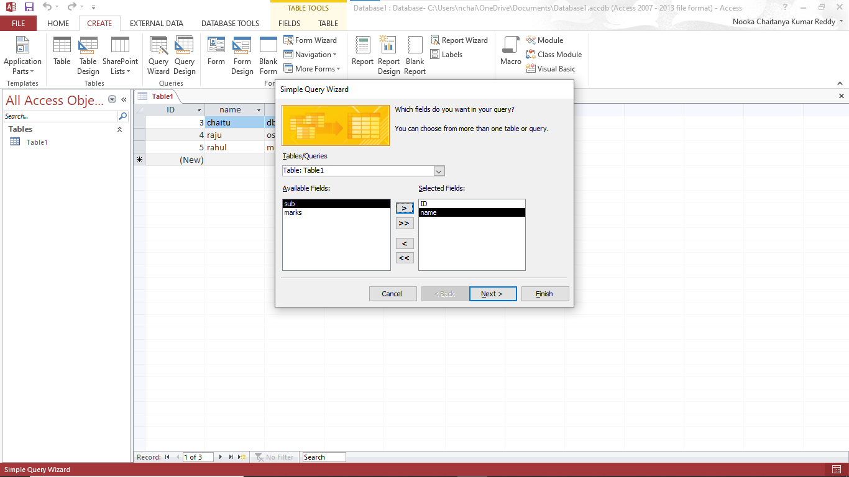

**Select the needed fields and press next button and press finish in next step**

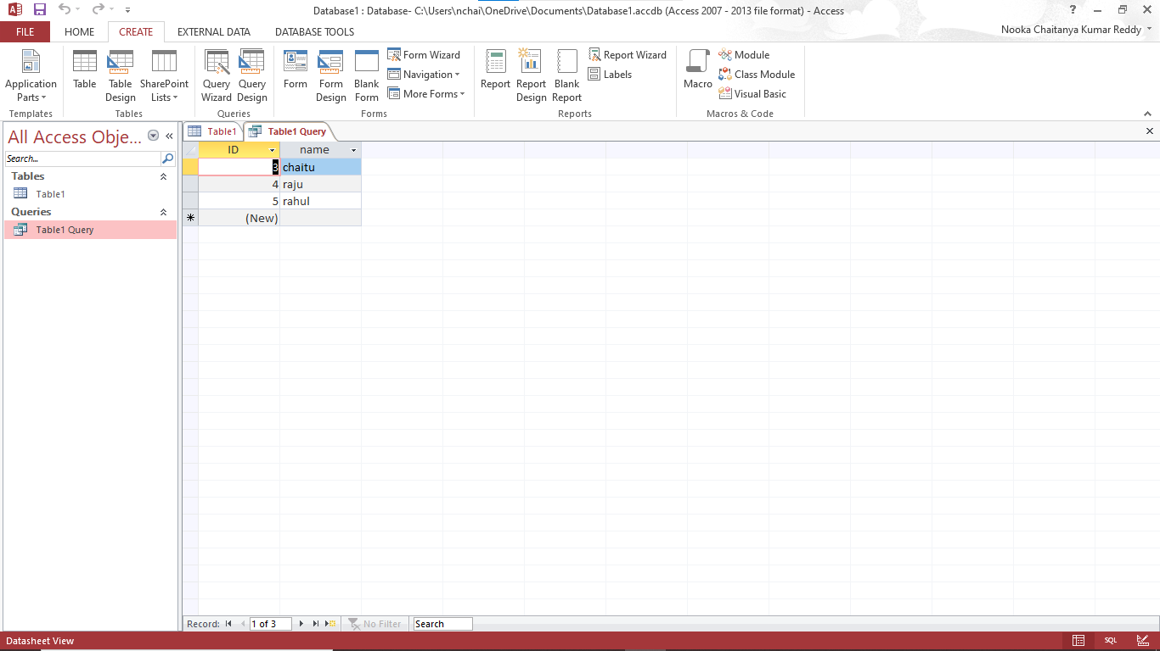

**Goto view and select sql view**

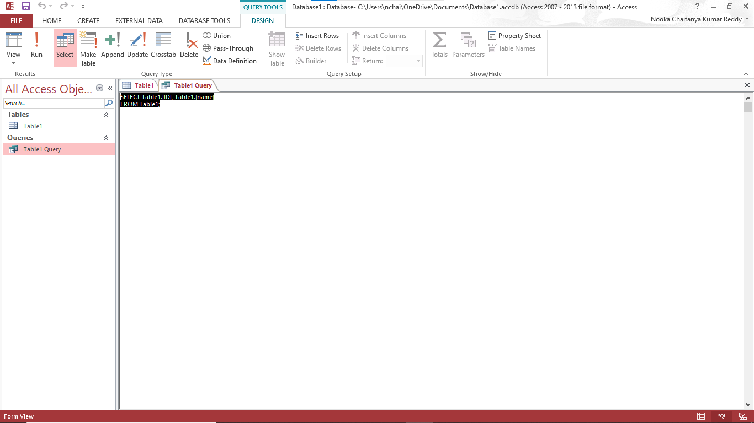

**Select the table and go create menu and select the report**

